Pharmaceutical Chemistry II.
Lecture II. "Psychomimetic-hallucinogenic and antiparkinson drugs"
Hallucinogens (psychodysleptic substances, psychomimetics, psychedelics, psychotomimetics) are substances that can cause hallucinations (even when taken in small doses).
Hallucinogens (in Latin hālūcinor, ālūcinor - "nonsense", "to fool", "delirious", "impossible dreams, etc. in Greek γένεσις - "origin") - are a class of psychoactive substances that cause hallucinations (blackouts) that can induce an altered state of consciousness. What distinguishes hallucinogens from other psychoactive substances is that they alter the way people think, feel, and perceive. Against the background of taking hallucinogens, changes such as depersonalization, derealization, hallucinosis, and illusions can be recorded. Among the known hallucinogenic substances, 3 should be mentioned in particular: mexalin, LSD and psilobin.
Hallucination or Delusion is false information, such as seeing, hearing, smelling, and touching something that does not exist in reality, but false information that is perceived as real.
The term hallucination is similar to illusion. Illusion refers to the wrong perception of a certain image by the eye. Illusions occur when a person's angle of vision changes. In hallucinations, a person believes that what he sees is real and feels as if he is experiencing it in reality. Hallucinations are common in psychosis. The patient mistakenly perceives many things that are not real as reality. Paranoid-schizophrenic patients claim that beings such as angels, demons, or devils have come to kill them or to do them good. Some temporary hallucinations may also occur under hypnotic sleep.
Delirium refers to scene-like hallucinations. The composition of hallucinations depends on what happened before intoxication: if the drug was taken after a fight, a conversation, then the hallucination will be fearful and anxious.
If the happy mood is taken with the psyche, the hallucinations will be happy.
The state of delirium is observed with visual hallucinations, and they quickly change and replace each other. A scene can be repeated several times.
Sometimes, in the case of delirium, the critical attitude to hallucinations can be lost, and then the patient can be harmful to those around him.
The use of hallucinogens has been known since ancient times, from the time of the Aztecs. Psychedelics, dissociative hallucinogens, and deliriums have a long history of use within medicinal and religious traditions.
In terms of religious practice, the use of psychedelic drugs, as well as other substances, such as tobacco (hypnotic), began in ancient times. These substances are called entheogens. In some places, peyote cacti have been classified as a 'sacred rite' of religious ceremonies.
Since hallucinogenic substances are naturally occurring, they are among the oldest drugs used by man. They are found in mushrooms, cacti and a number of other plants. Numerous cultures around the world have to varying degrees endorsed the use of hallucinogens in medicine, religion, and recreation, with some cultures regulating or outlawing their use. Today, in most developed countries, the use of hallucinogens, which are very common in nature, has been banned. However, in Brazil, the religious use of ayauasca (a hallucinogenic drink made from the Banisteriopsis caapi plant and containing dimethyltyptamine) has been legal since 1987.
Although natural hallucinogenic drugs have been known for a long time, attention to them increased only at the beginning of the 20th century. Initial studies of the components of the peyote cactus, which contain hallucinogenic substances, began at the end of the 19th century. Beginning in 1927, Kurt Beringer's began to study mescaline intoxication. At the same time, Louis Lewin published his extensive study of psychoactive plants. In later years, the Mexican psilocybin mushroom (Robert J. Weitlaner in 1936) and the Christmas grape (Richard Evans Schultes in 1939) were discovered. Undoubtedly, the most important discovery was Albert Hofmann's 1943 discovery of the semisynthetic substance Lysergic acid diethylamine (LSD).
After World War II, interest in hallucinogenic drugs increased. By 1951, more than 100 LSD derivatives appeared, and by 1961, their number was over 1,000. The existence of hallucinogenic drugs was not disclosed to the general public until the early 1950s. In the early 1960s, psilocybin and LSD were tested on volunteers. In 1965, the US Supreme Federal Authority banned the use of LSD.
In the 1960s and 1970s, cigarettes called "astmatol" were sold in the former USSR, which contained marigold, St. John's wort and sodium nitrate, and were used in the treatment of bronchial asthma. Since it contains hallucinogens, drug addicts made a decoction of it to induce asthmatic delirium.
For a drug to be certified as a hallucinogen, it must meet these five criteria:
• changes in thinking, perception and mood should prevail over other effects;
• the negative impact on intellectual or memory impairment should be minimal;
• stupor, narcosis or overstimulation should not be in the form of a general effect;
• side effects on the autonomic nervous system should be minimal;
• should not be addictive.
Hallucinogenic substances include:
- Psychedelics
-Dissociative hallucinogens
-Delirians
In addition to these large groups
-Amphetamines - can cause hallucinations
- Flycatcher mushroom - has hallucinogenic effects because it contains ibotenic acid and muscimol.
Psychedelics are hallucinogenic substances whose main effects are the creation of unusual states of consciousness (psychedelic hallucinations or "trips"). Their use leads to psychological, visual and hearing disorders.
Their main classification is as follows:
Tryptamines.
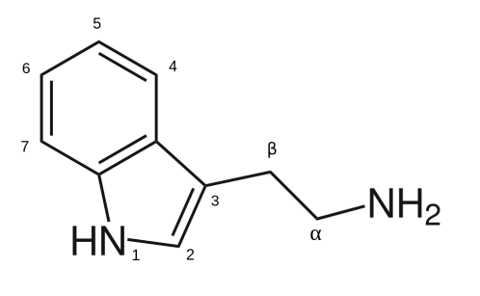
Chemically, they are tryptamine (indole) derivatives. Psilosin, Psilocybin, Bufotenin, Dimethyltryptamine (DMT), Methoxydimethyltryptamine (MeO-DMT) and many other substances belong to this group.
Phenethylamines.
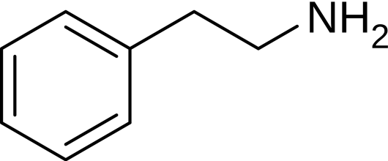
From a chemical point of view, these substances are derivatives of 2-phenylethylamine. This group includes Amphetamine, Methylamphetamine, 2C, 25-NB, Methylenedioxymethamphetamine (Ecstasy), Methylenedioxyamphetamine (Sass), etc.
Lysergamides

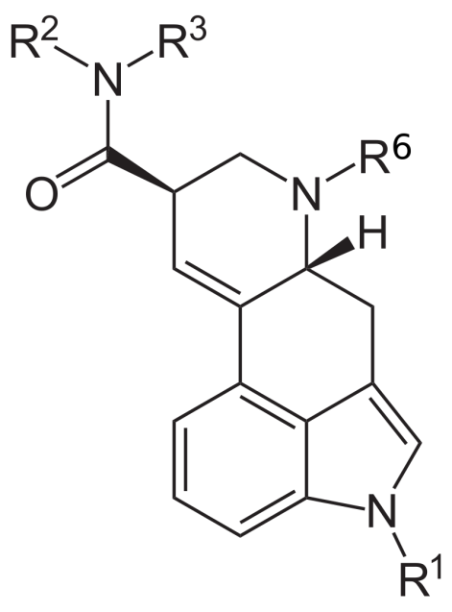
Chemically, these substances are amides of lysergic acid. This group includes LSD (diethylamide of lysergic acid), lysergamide.
The term psychedelic was first proposed by American psychiatrist Humphrey Osmond. The mechanism of action of most psychedelics is related to the agonism of serotonin 2A receptors. By binding to serotonin 5-HT2A receptors, they modulate the activity of important circuits in the brain that regulate sensory perception and mental activity. Psychedelic experience is often compared to unusual forms of awareness, such as meditation, mystical perception, etc. The use of most psychedelic drugs is banned worldwide under UN conventions, except for religious ceremonies or for research purposes. However, their illegal use is common. This is due to the fact that psychedelics are physiologically safe and addictive. At the same time, research conducted on them has information about the effectiveness of psychedelics in the treatment of depression, alcohol and nicotine addiction.
Although psychedelics are legally considered narcotics, they do not cause any physical or mental dependence, but they can be very scary when used. During their use, they can cause derealization, depersonalization and other psychotic states.
Some possible effects of psychedelics:
- Illusions
- Synesthesia
-Feeling of fear, depression, euphoria, mood disorders
- Violation of coordination
- Auditory and visual pseudo-hallucinations
- Summary of past events
- Violation of perception of the environment.
Dissociative hallucinogens inhibit the transmission of signals from one part of the brain to another, leading to sensory deprivation and hallucinatory images.
In addition to hallucinations, these substances can lead to a number of unpleasant situations. For example, during the use of phencyclidine, side effects such as numbness of limbs, visual disturbances, ataxia, dysarthria, nystagmus, sweating, hypersalivation, erection, muscle stiffness can be observed.
The main groups of dissociative substances include NMDA antagonists (ketamine, methoxetamine, dextromethorphan, ibogaine, phencyclidine) and agonists of k-opoid receptors (salvinorin A, nalbuphine).
In addition to these, they note the following dissociative substances:
-σ-opoid receptor agonists
- substance obtained from fly swatter
- cholinolytics (alkaloids of the tropane group - atropine, scopolamine and hyoscyamine).
Dissociative hallucinogens are used in medical practice as anesthetics (ketamine), and some as cough suppressants (dextromethorphan). Ketamine is also promising to be used as an antidepressant in the future.
Delirium-causing hallucinogens are considered short-term exogenous psychotic agents. The use of all types of deliriums was harmful. Cholinolytics such as atropine and scopolamine have hallucinogenic effects in high doses. During atropine delirium, the following somatic symptoms are observed: tachycardia, breathing disorders, difficulty swallowing, convulsions, ataxia, dysarthria, amnesia. Trihexyphenidyl and diphenhydramine also cause delirium.
There is also such a classification of these substances:
Antagonists of muscarinic acetylcholine receptors: atropine, hyoscyamine
Non-specific muscarinic antagonists: scopolamine.
Currently, the terms "psychomimetic" and "psychotomimetic" are considered obsolete.
In recent years, according to the mechanisms of action, hallucinogenic substances are divided into the following groups:
Serotoninergic substances - LSD, psilobisin, mexaline
Anticholinergic substances - atropine, scopolamine.
Dissociative anesthetics - phencyclidine, ketamine
Methyl-derived amphetamines - MDMA, MDA
Mechanisms of action can be broadly classified as follows:
-Agonists of serotonin receptors (5-HT1A, 5-НТ2А, 5-HT2C, 5-HT5A, 5-НТ5, 5-НТ6).
-N-methyl-D-aspartate (NMDA) receptor antagonists (these substances are believed to cause irreversible brain damage).
Blockers of M-cholinoreceptors and n-cholinoreceptors.
Hallucinogenic plants:
Representatives of the hemp class - Cannabis sativa, Cannabis indica and Cannabis ruderalis.
Representatives of the class of acanthus - Fittonia albivenis, Justicia pectoralis.
Aceraceae representatives: Acer saccharinum.
Representatives of the Aizonkin class: Delosperma species.
Representatives of the class of creepers: Prestonia amazonica, Voacanga africana.
Representatives of the leguminous class: Petalostylis cassioides, Petalostylis labicheoides.
Representatives of the Acacia class: Acacia acuminata, Acacia aroma.
Various species: Anadenanthera peregrina, Lespedeza capitata, Mimosa tenuiflora, Diplopterys cabrerana, Echinopsis lageniformis, Elaeagnus angustifolia.
Hallucinogenic mushrooms: Psilocybe cubensis, Amanita muscaria, Conocybe, Agrocybe, Psathyrella, Gymnopílus, Inocybe.
Individual psychomimetic-hallucinogens.
Psilocin (4-HO-DMT)
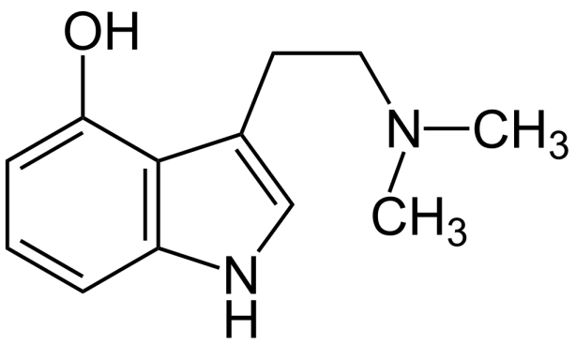
4-Hydroxy-N,N-dimethyl-tryptamine
Psilocin is a psychoactive substance that is an alkaloid of the tryptamine group. Along with psilocybin, it is found in many hallucinogenic mushrooms (Psilocybe semilanceata).
Synthesis:

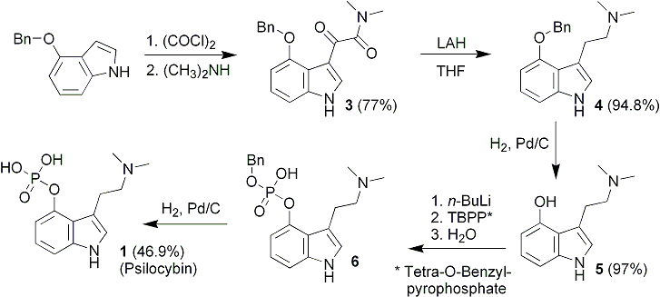
Psilobicin is dephosphorylated in the gut to psilocin, and the derived psilocin exerts psychoactive effects
Its chemical structure is similar to serotonin
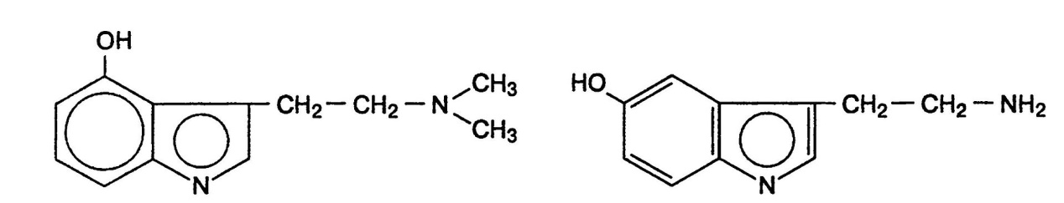
It was extracted from the Psilocybe mexicana plant by Albert Hofmann in the late 1950s.
Metabolism:
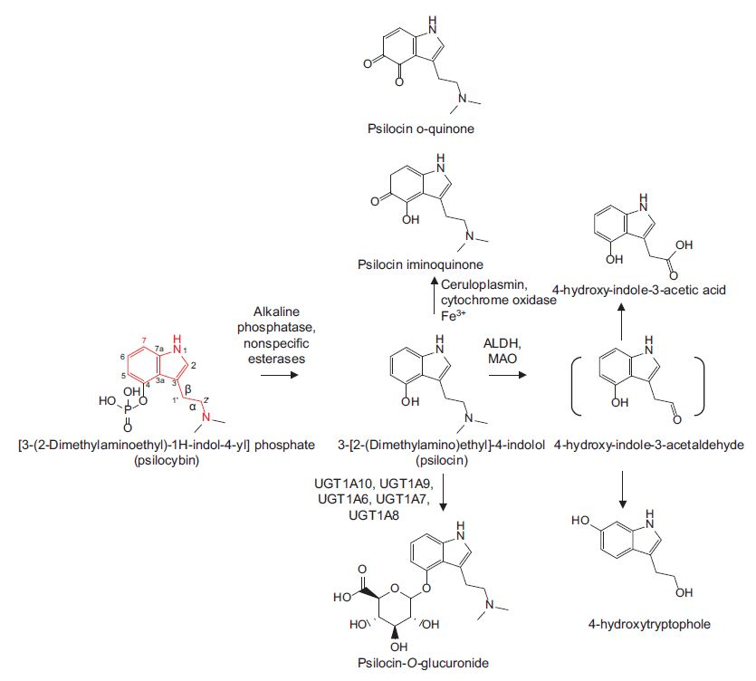
Psilocin has an affinity mainly for 5-HT2A, and to a lesser extent for 5-HT1A, 5-HT1D and 5-HT2C serotonin receptors. In high doses, it can also affect noradrenaline receptors.

Psilocybin
[3-(2-dimethylaminoethyl)-1H-indol-4-yl] dihydrophosphate
Psilocybin is a natural psychedelic prodrug . There are more than 200 types of mushrooms. Tryptamine group belongs to alkaloids.

Synthesis by Hoffman's method: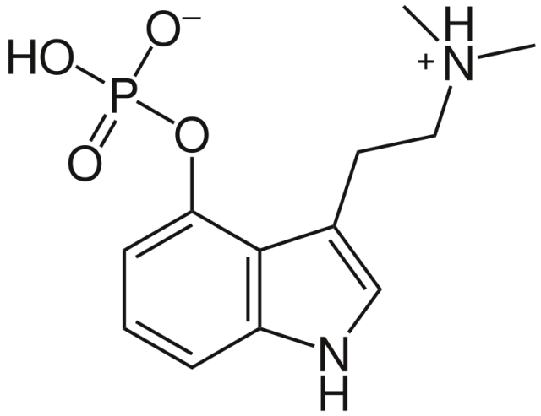

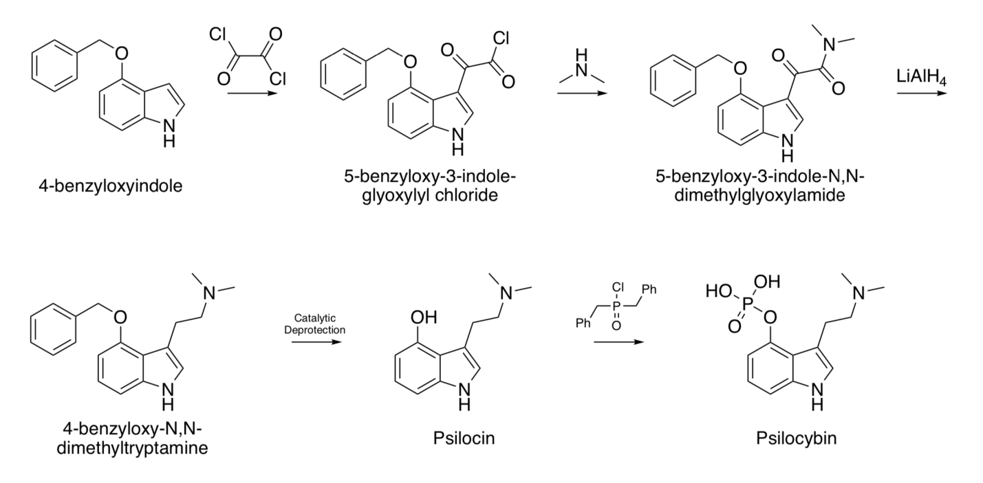

Due to its chemical structure and effect on the body, it is similar to dimethyltryptamine, which is endogenously synthesized by the pineal gland.
Psilocybin is a prodrug that is dephosphorylated in the body to psilocin, the pharmacologically active substance.
Metabolism:
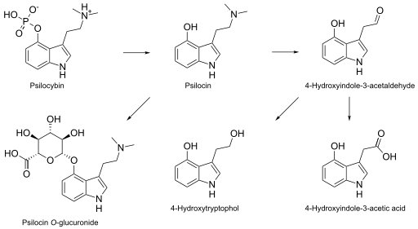
Psilobicin is an agonist of serotonin receptors. Psilocin has an affinity mainly for 5-HT2A, and to a lesser extent for 5-HT1A, 5-HT1D and 5-HT2C serotonin receptors. It mimics serotonin receptors. This substance has a high pharmacotherapeutic potential. In 2011, the FDA lifted its ban on scientific research on psilocybin. It can be used to treat depression, fear of death, migraine and alcoholism.
Bufotenine (5-HO-DMT)
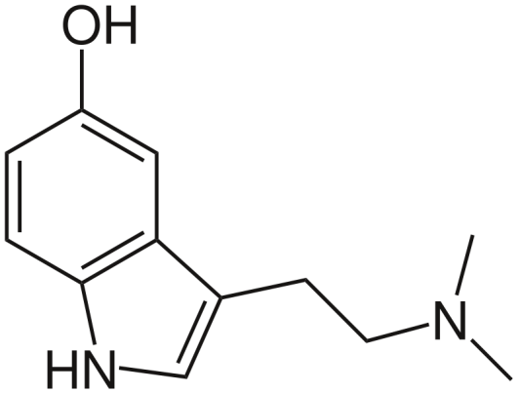

3-(2-dimethylaminoethyl)-1H-indol-5-ol
Bufotenine is a substance that is a representative of the tryptamine class. It is structurally similar to serotonin. Bufotenine is found in several frog species. It is mainly found in the skin of colorado and aga frogs (Bufo).
Synthesis of bufotenine:
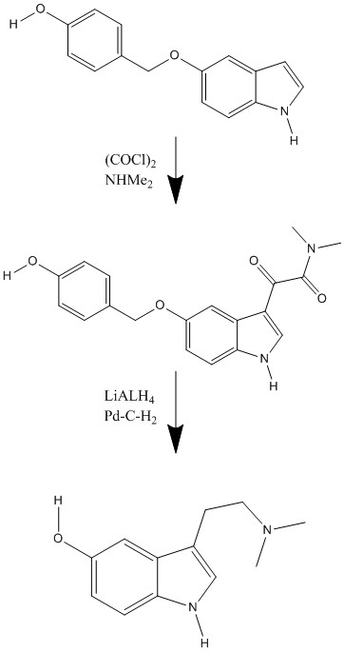
Bufotenine metabolism:

Bufotenin is also found in the seeds of Anadenanthera peregrina. Aborigines of Peru and Haiti use this plant to prepare a special powder "Yopo". They use this powder intranasally in religious ceremonies. According to the data of recent years, the use of bufotenin in schizophrenic patients causes a short-term strengthening of self-restraint and minor somatic disorders.
Mescaline
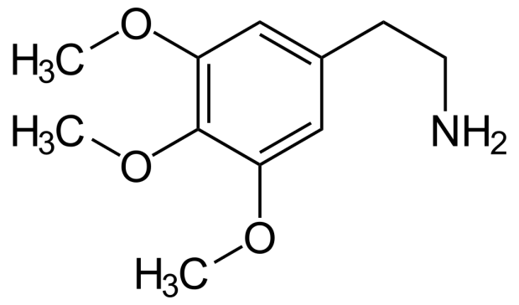
2-(3,4,5-trimethoxyphenyl)-ethylamine
Mescaline is a psychedelic entheogenic substance from the phenylethylamine group. A small amount is found in Lophophora (Lophophora williamsii) and Echinopsis (Echinopsis pachanoi, Echinopsis peruviana) cactus species. It can be synthesized from gallic acid or vanillin. It was first extracted from peyote cactus (Lophophora williamsii) in 1897 by Arthur Heffter, a German chemist. It was chemically synthesized by Ernst Shpet in 1919.
Synthesis of mescaline:
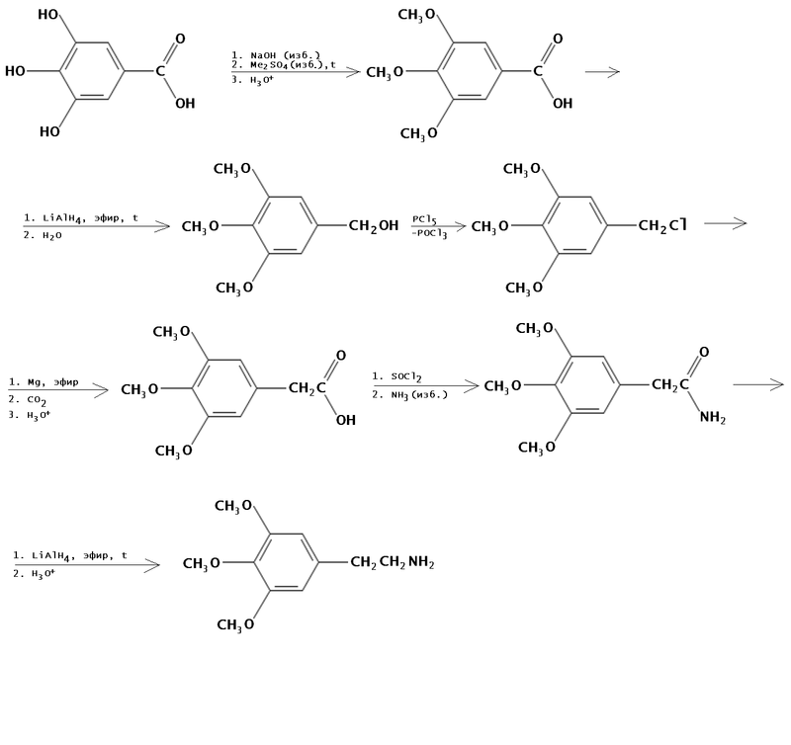
Metabolism:
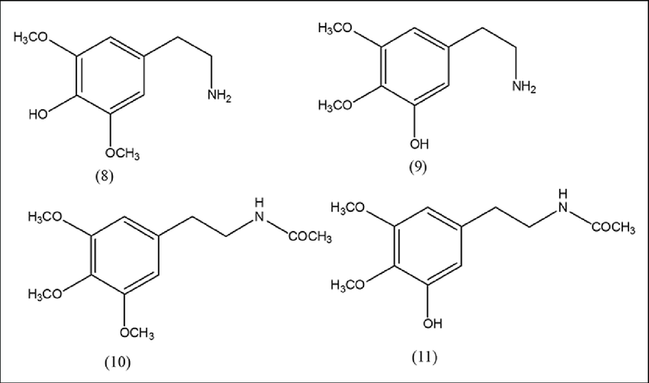

Psychotropic effects of mescaline:
-Hallucinations with open eyes
-Hallucinations with closed eyes
- Mental process change
- Euphoria
- Mystical feelings
-Irrationality of the mental process
-Acceleration of the manual process
-Slowness of movements
In most countries of the world, the production and circulation of mescaline is prohibited by law.

Dimethyltryptamine (DMT)
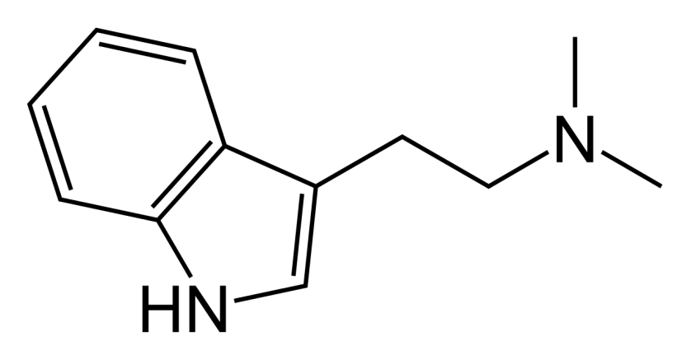
2-(1H-indol-3-yl)-N,N-dimethyl-ethanamine
N,N-dimethyltryptamine is an endogenous psychedelic synthesized by the pineal gland during REM sleep. In the human nervous system, 5-HT2A acts as an agonist of serotonin receptors. An alkaloid of many plants of the tryptamine class. DMT is similar in chemical structure to serotonin. A small amount is synthesized in the human body against the background of normal metabolism.
DMT is a psychedelic psychedelic with a religio-mystical experience, causing visual and auditory hallucinations and altering time and reality.
DMT is found in many plants, mostly in association with 5-MeO-DMT and bufotenine (5-HO-DMT). These plants (such as ayahuasca) are used by shamans in South America for religious ceremonies.
Pure DMT is a colorless, white or yellow-red crystalline powder. In nature, L-tryptophan is synthesized from amino acid. DMT was first synthesized in 1931 by the English scientist Richard Mansky.
Synthesis:

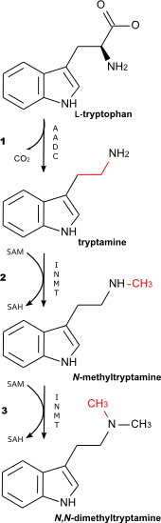
DMT is usually inactive when taken orally and is rapidly metabolized by the body. In order to obtain a psychoactive effect, it should be used together with a monoamine oxidase inhibitor when taken orally. It can be smoked like a cigarette or injected, in which case the psychedelic effect is strong but short-lived. The psychedelic effect is enhanced when used together with pindolol. Currently, it is considered an illegal substance and is banned in the world.

Methoxydimethyltryptamine (MeO-DMT)

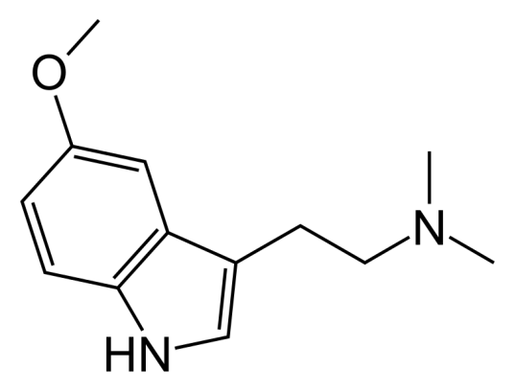

2-(5-Methoxy-1H-indol-3-yl)-N,N-dimethylethanamine
5-MeO-DMT is a potent psychoactive substance from the tritamine class. 5-MeO-DMT is secreted by many plants and the skin of frogs (e.g., Bufo alvarius). It is a substance close to dimethyltryptamine and bufotenin. In South America, this substance has been used as an entheogen for 1000 years.
It was first synthesized in 1936, and in 1959 it was extracted from the seeds of the Anadenanthera peregrina plant as a psychoactive substance.
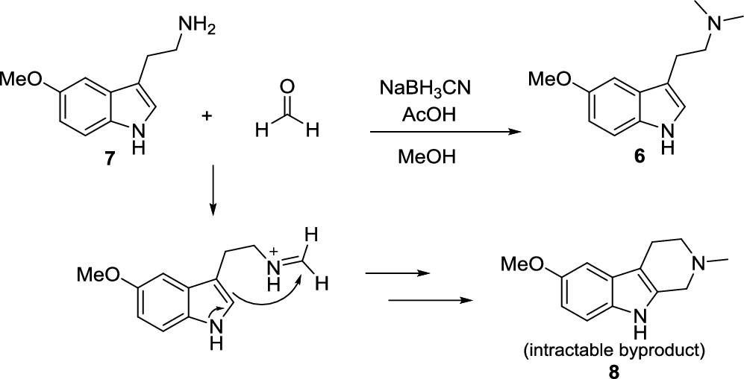
5-MeO-DMT is the methoxy analogue of DMT. Metabolism:
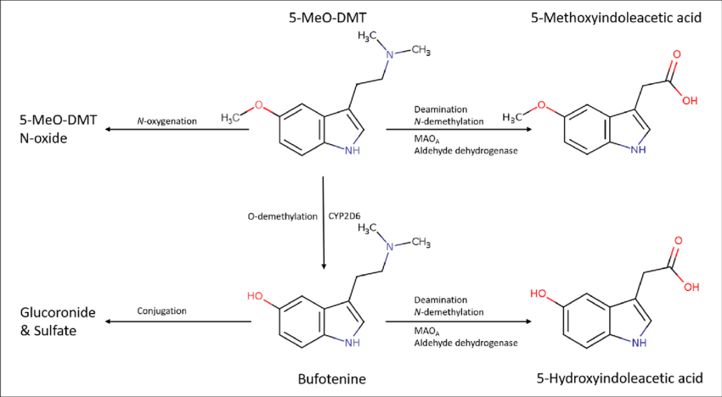
The pharmacological effect is achieved by affecting serotonin receptors. It shows high affinity for 5-HT1 and 5-HT2 subtypes. It can also be involved in the processes of inhibiting the reuptake of monoamines.

Amphetamine (Adderal)

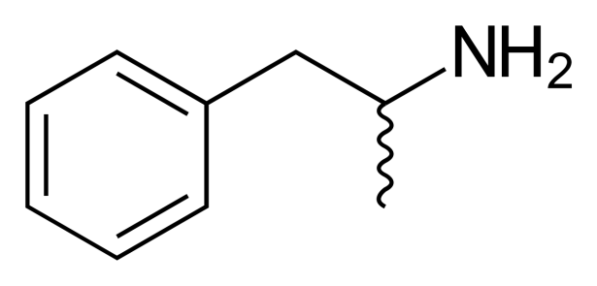
(±)-1-phenylpropan-2-amine
Amphetamine is a synthetic CNS stimulant and anorexic substance. It is a derivative of phenylethylamine. The mechanism of action is related to the release of neurotransmitters (dopamine, noradrenaline and serotonin). In most states, it is used to treat attention deficit hyperactivity disorder and narcolepsy. The circulation of amphetamine is limited by international and national legislation.
It was first purchased in Germany in 1887 as a racemic compound by the Romanian chemist Lazer Edelianu. Its psychoactive properties were discovered by Gordon Alles in 1929. In 1937, it began to be used as a suggested medication for narcolepsy, Parkinson's disease, depression and beeswax.
Its synthesis is carried out by condensation of phenylacetone with formamide or ammonium formate and subsequent acid hydrolysis based on the Leukart reaction.
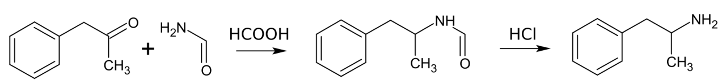

The main metabolism of amphetamine is based on the conjugation of the inactive metabolite formed after deamination with glucuronic acid.
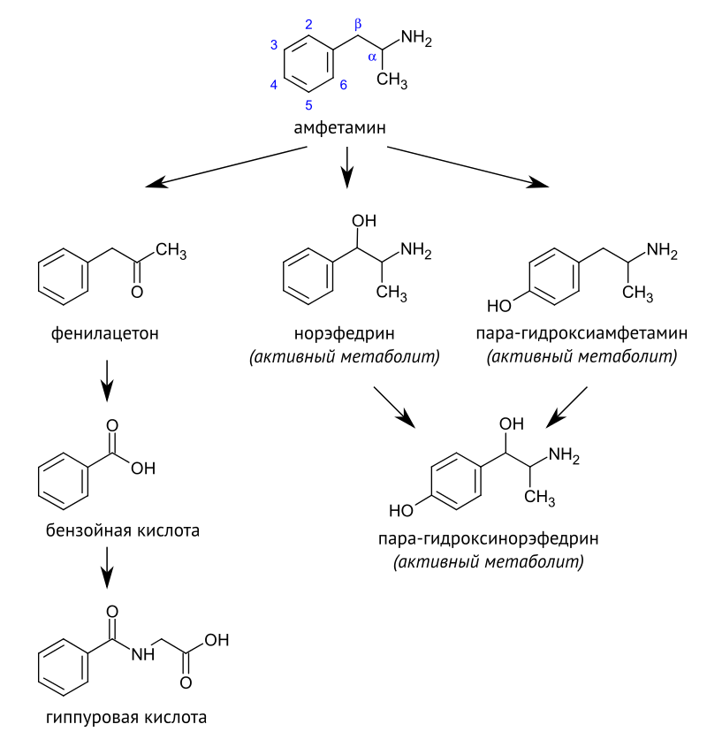

It is mainly used orally, consumed in the form of tablets and long-acting capsules.

Methylamphetamine
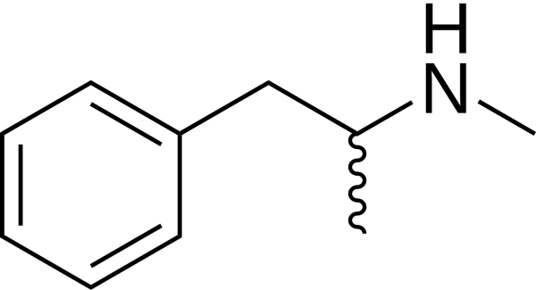
N-methyl-1-phenylpropan-2-amine
Methamphetamine is a psychoactive substance derived from amphetamine and belongs to narcotics. Access is currently limited.
It was first synthesized from ephedrine in 1893 by the Japanese chemist Nagai Nagayesi. It was synthesized in crystalline form by the Japanese scientist Akira Ogata in 1919.
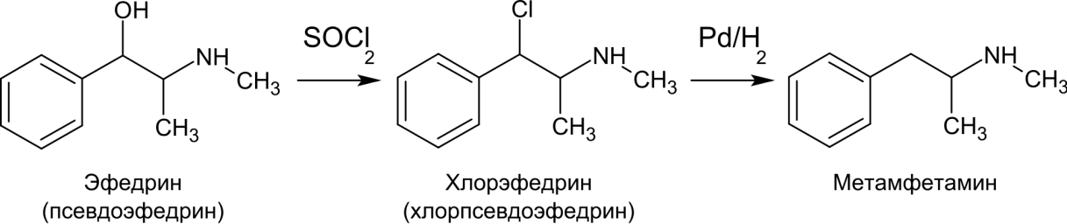
Metabolizmi:
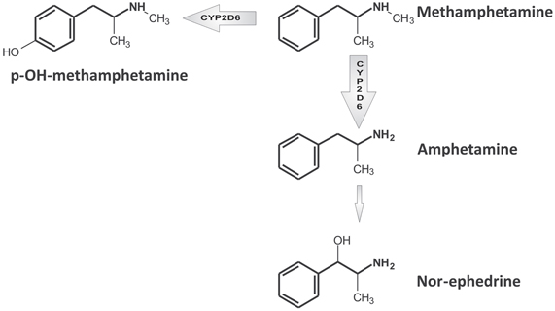
In the US, it is used in medical practice under the name "Desoxyn". It is used by the FDA to treat Attention Deficit Hyperactivity Disorder, obesity. It is used off-label to treat narcolepsy and hypersomnia
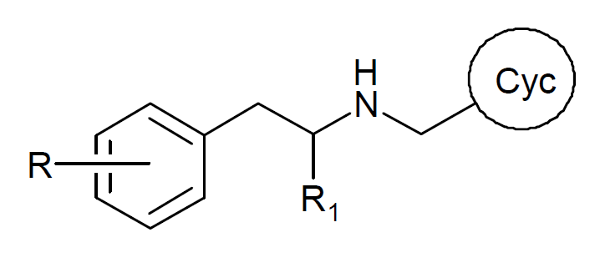
It is a class of psychoactive substances.

Methylenedioxymethamphetamine (Ecstasy)
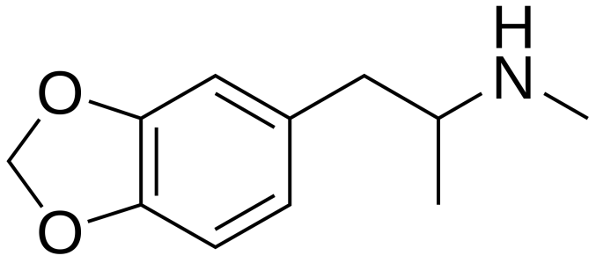

Methylenedioxymethamphetamine is a psychoactive drug from the amphetamine group, a derivative of phenylethylamine. It is distributed under the name "Ecstasy". Circulation and production are prohibited.

Methylphenidate
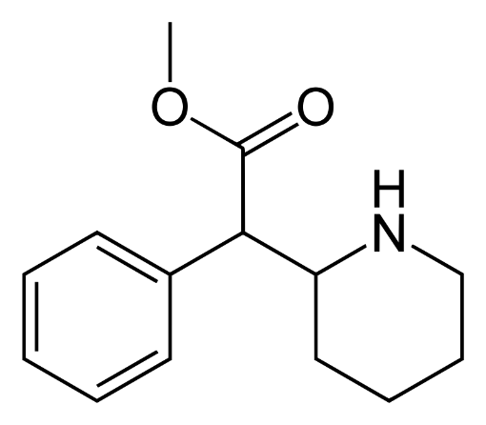
Methyl 2-phenyl-2-(piperidin-2-yl)acetate
Methylphenidate is a drug sold under the name "Ritalin". It is an inhibitor of noradrenaline and dopamine reuptake. It is used for the treatment of Attention Deficit Hyperactivity Disorder, narcolepsy.
LSD

Indole derivatives also include a group of alkaloids obtained from Claviceps purpurea mushroom of Clavicepitaceae family at the beginning of the 20th century. Rye fungus belongs to the class of Ascomycetes and is the overwintering form of the fungus that is parasitic on cultivated cereals. These alkaloids are called ergoalkaloids and there are more than 30 representatives in our rye vine.
Lysergic acid amide derivatives have side effects on the body. Thus, they cause hallucinations related to hearing and vision, temporary disturbances of tissue nutrition and psyche. Such an effect is stronger in lysergic acid diethylamide (LSD-25).
It was first synthesized in 1938 by Albert Hofmann. Synthesis:
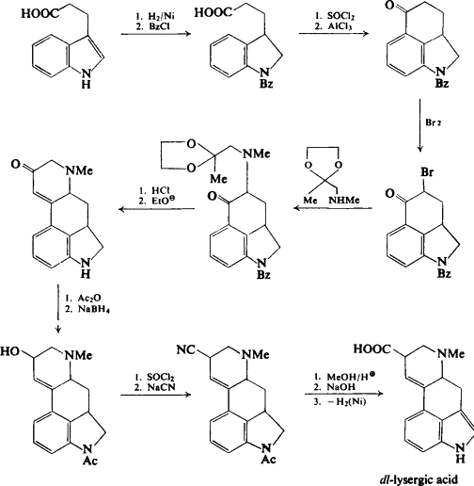
Metabolism:
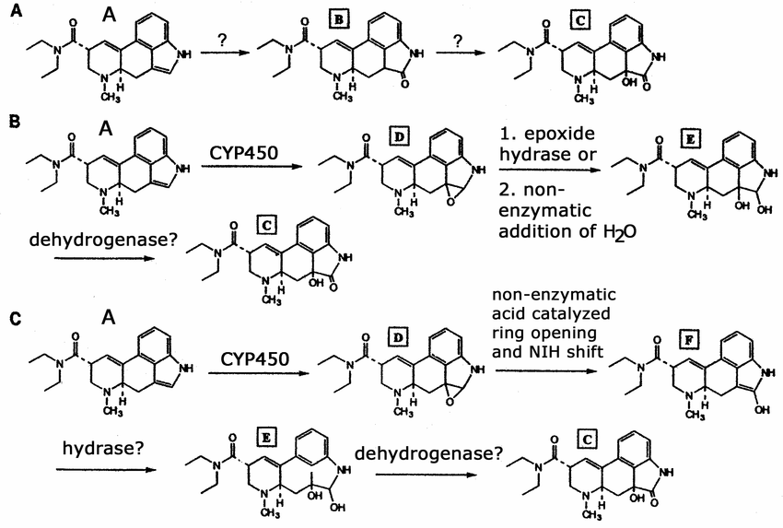
It is the best known psychedelic. Production and use are currently prohibited.

Ketamine (Calypsol

(РС)-2-(2-Chlorophenyl)-2-methylamine-cyclohexanone-hydrochloride
Synthesis: 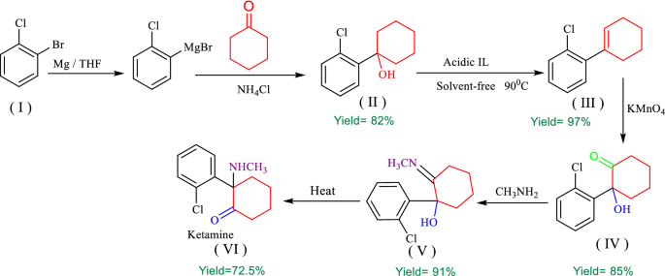

It is a white crystalline powder with a weak pungent odor. It is easily soluble in water and alcohol.
Metabolism:
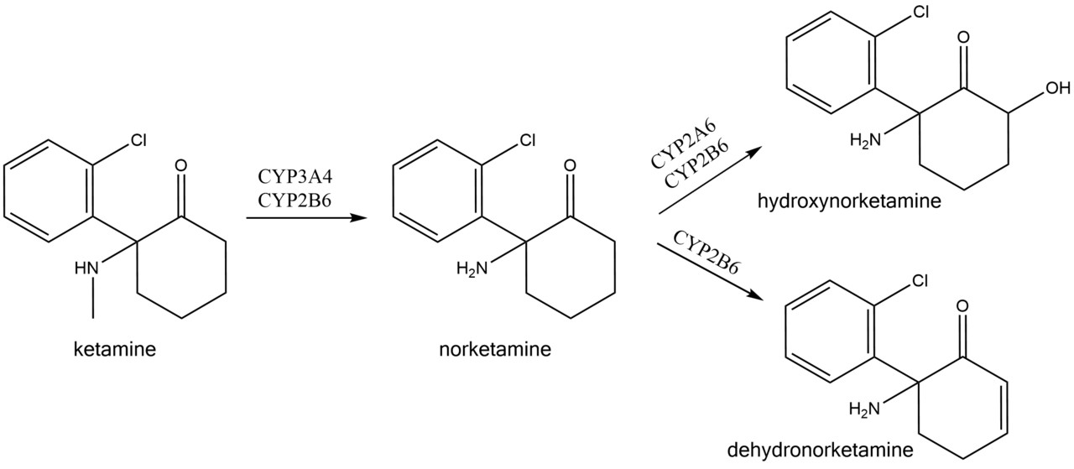
It has a general anesthetic and analgesia effect. Its analgesic effect develops within 10 minutes after intravenous injection and lasts for 2-3 hours. Its impact is more effective when injected into the skin. The drug is used for mono- and combined anesthesia in urgent surgery, when arterial pressure is low, during traumatic shocks, when there is a lot of blood loss.
5% solution is released in 2 and 10 ml ampules, 1% solution in 20 ml and 5% solution in 10 ml vials.

Methoxetamine
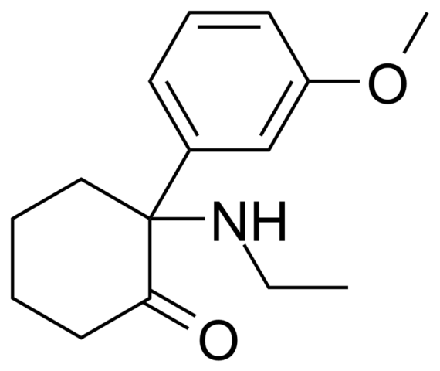
(RS)2-(3-Methoxyphenyl)-2-(ethylamine)cyclohexanone
Methoxetamine is a dissociative agent from the arylcyclohexylamine group. It is a stronger acting analogue of ketamine. It is an antagonist of NMDA receptors, an inhibitor of dopamine reuptake. It is a substance prepared for sale on the black market.
Synthesis:
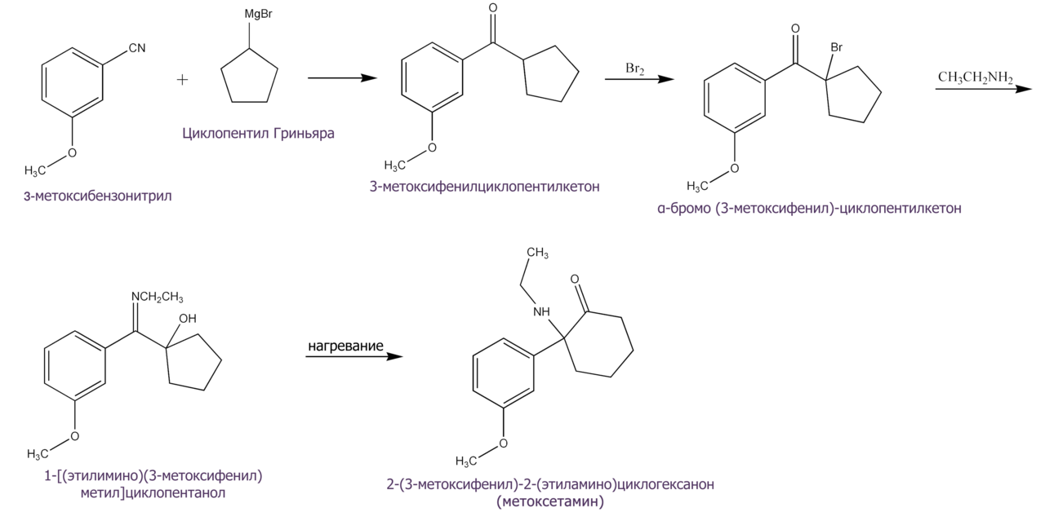

Dextromethorphan
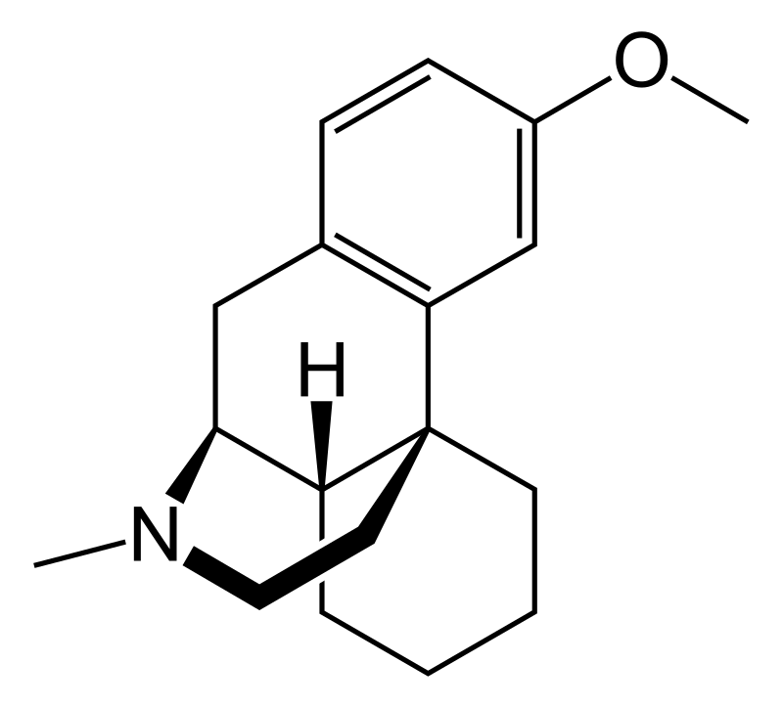
(+)-3-methoxy-17-methyl-(9α,13α,14α)-morphinan
Dextromethorphan is a cough medicine. It is an optical isomer of levometorphan. It has no opiate effects. It mainly replaces codeine as an antitussive. Relieves the cough center, eliminates all types of cough.
In addition, dextromethorphan is used in medicine for diagnostic purposes, as well as for the treatment of heroin addiction and alcoholism, as well as some chronic neurodegenerative diseases.
Ibogaine
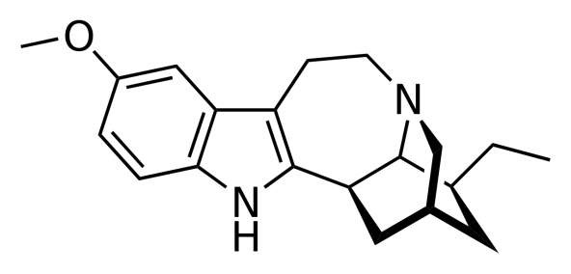
12-Methoxyibogamine
Ibogaine is an alkaloid of the indole group found in plants belonging to the Apocynaceae family. The plant that contains the most ibogaine is iboga (Tabernanthe iboga). Its roots are used in African religious rituals.
Due to its hallucinogenic properties, ibogaine has been banned in the United States and many countries. However, its use is allowed in 12 countries of the world, as well as in Canada. Its use is legal in Italy and Austria.
Phencyclidine
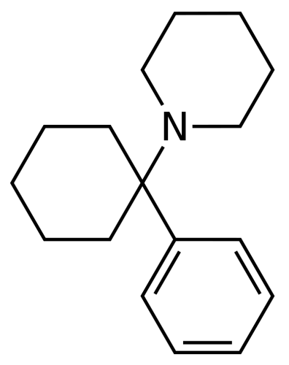
1-(1-phenylcyclohexyl)-piperidine
Phencyclidine is a synthetic NMDA receptor antagonist used as an intravenous anesthetic. It was created in the USA in 1950 and was used for medical purposes under the name "Sernyl". Its use has been discontinued due to high neurotoxicity.
Currently, in many states, it is included in the list of drugs as narcotics.
Salvinorine A
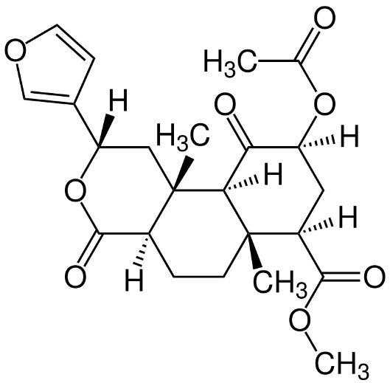
It is a psychoactive trans-neoclerodan diterpenoid. It is found in the Salvia divinorum species of the sage plant. A very strong hallucinogen. Its effect is related to the activation of kappa-opiate receptors.
Nalbufin
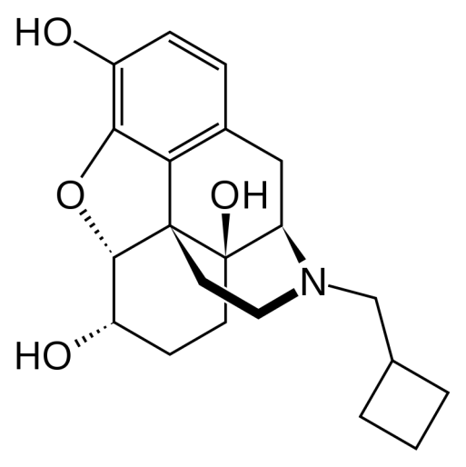
(–)-17-(cyclobutylmethyl)- 4,5α-epoxymorphinan- 3,6α,14-triol hydrochloride

Naflubin is an opioid analgesic. Due to its chemical structure, it is very close to morphine, it retains the N-methylcyclobutyl group instead of the N-methyl group.
It is an agonist-antagonist of opiate receptors. The analgesic effect is related to the agonistic effect on kappa-receptors. At the same time, it does not have a pronounced euphoric effect because it has an antagonistic effect on m-receptors. It is close to pentazocine in its effect. In military personnel, it is a component of the medical instructor's medicine bag.
Atropine
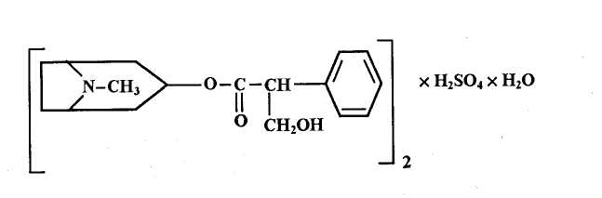

(8-methyl-8-azabicyclo[3.2.1]oct-3-yl) 3-hydroxy-2-phenylpropanate

Atropine, hyoscyamine and scopolamine are found in the plants belonging to the Solanaceae family - lady's wort, bat-bat, dalibeng, and scopolia. The determination of the structure and synthesis of atropine is due to many years of research by Landenburg, Merling and Wilstetter. As a result of these works, in 1916, Robinson proposed an easy synthesis method for atropine. By this method, tropinone is first obtained from succinic aldehyde, methylamine and acetone, it is reduced to tropine, and under the action of tropic acid it is transformed into atropine:
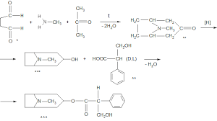
Atropine, or d,tropine ester of L-tropic acid, is a monoacidic triple base, giving salts with acids that are readily soluble in water.
In order to obtain atropine in industry, the roots and rhizomes of scopolia (Scopolia carniolica Jacq.) are taken as plant raw materials. The plant raw materials contain up to 0.9% alkaloids, which are mainly l-hyoscyamine and scopolamine, and atropine is in organic amounts. The alkaloids from the plant raw materials are mainly in the form they extract, that is, first the raw material is treated with an ammonia solution, and then extraction is carried out with organic solvents (dichloroethane, chloroform, etc.). Then, hyoscyamine obtained is converted into atropine, which is a racemate, by treating it with sodium hydroxide in aqueous alcohol solution. The obtained atropine-base is purified, dissolved in anhydrous alcohol and converted into atropine-sulfate with pure sulfuric acid.
Atropine sulfate is an odorless, white crystalline or granular powder, easily soluble in water and alcohol, insoluble in chloroform and ether. Aqueous solutions are neutrally reactive; 0.1 N hydrochloric acid is added to stabilize the injection solutions.
Metabolism of atropine In phase I, metabolites are formed by hydrolysis and demethylation reactions, which are then excreted from the kidneys in the form of glucuronides.
1. Tropine alcohol is formed as a result of hydrolysis reaction in phase a).

b) noratropin is formed in the demethylation reaction.
Formation of glucuronides of artopin and tropic acid in phase II:
Atropine is a cholinolytic substance: it is included in various drugs with spasmolytic and mydriatic (pupil dilation) effects. Due to its central anticholinergic effect, it eliminates tremors during Parkinson's disease. 0.1% solution for injection is released in 1 ml ampoules. In ophthalmology, it is used as a pupil dilator for the purpose of examination, as well as for the treatment of inflammatory diseases of the eye (0.1% solution). Internally and under the skin, only 0.1% solutions are used in gastric and duodenal ulcers, to eliminate spasms of intestinal and urinary tracts, in bronchial asthma, etc. Being applied.
Scopolamine (Atrossin)
It is used in the form of hydrobromide salt.
To buy the drug, the raw materials and method used in the production of atropine are used. Alkaloids are first divided into hyoscyamine and scopolamine.
Scopolamine hydrobromide is colorless, transparent crystals or white crystalline powder. Soluble in water and alcohol, slightly soluble in chloroform.
Scopolamine-hydrobromide is used as a 0.05% injection solution. 0.1 N hydrochloric acid solution is added to this solution as a stabilizer. Scopolamine is a cholinolytic substance close to atropine in terms of its pharmacological effect. Unlike atropine, it has a calming effect on the central nervous system. Scopolamine is used as a premedication in the treatment of Meniere's and Parkinson's diseases. Scopolamine and hyoscyamine are included in the composition of "Aeron" tablets (Tabulettae "Aeronum"), which are used as a sedative and antiemetic in the form of camphoric acid salt.

Trihexyphenidyl (Cyclodol)
C
O
H
C
H
2
C
H
2
N
R
1
2
3
.
H
C
l

1-Phenyl-1-cyclohexyl-3-piperidine-propan-1-ol-hydrochloride
White pomegranate is a crystal powder. Slightly soluble in water, gradually soluble in alcohol.
For its synthesis, they condense pyridine with formaldehyde and acetophenone:

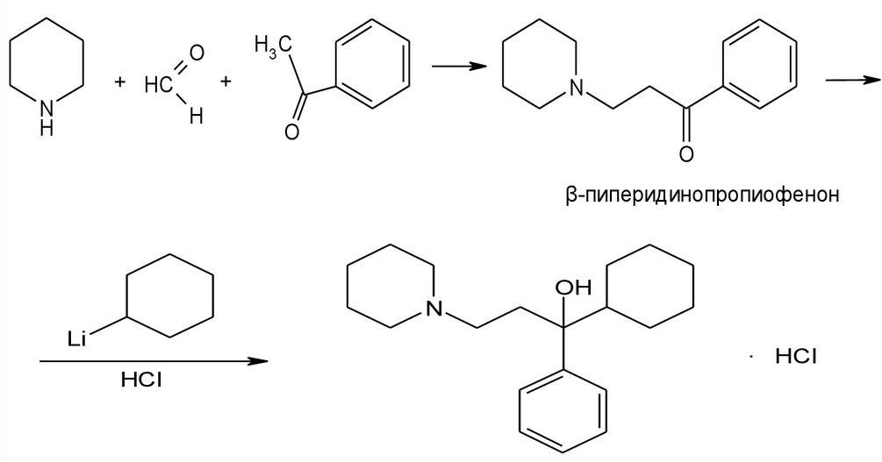

It is a cholinolytic substance and is used in the treatment of parkinsonism. 0.001; It is released in 0.002 and 0.005 g tablets. The drug is stored in strict compliance with the rules for the storage of narcotic analgesics.

Diphenhydramine (Dimedrol)

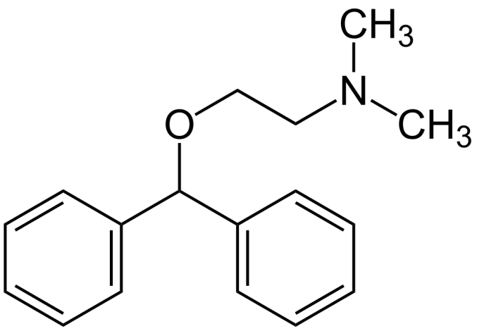
N,N-dimethyl-2-(diphenylmethoxy)-ethylamine hydrochloride.
It is a first-generation antihistamine drug.
Synthesis:
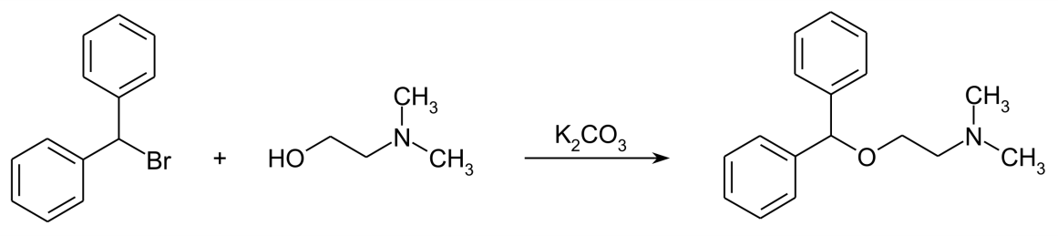
Metabolism:

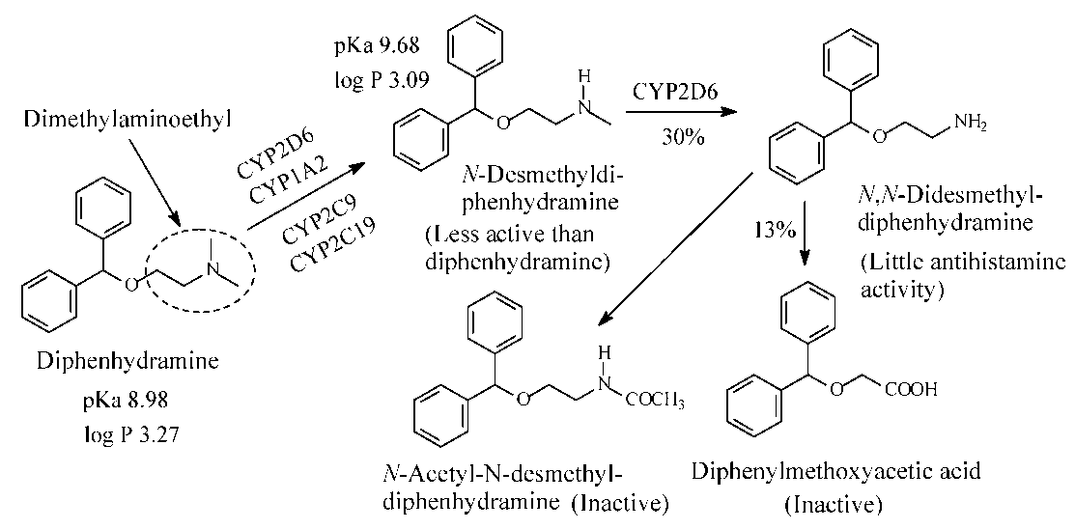
It is generally divided into 2 groups, familial and sporadic. However, it is known that familial PH cases do not always correspond to genetic etiology, and long-term exposure of family members to the same environmental factors causes the disease. So, IPH is divided into familial IPH and sporadic IPH due to the influence of environmental factors. In sporadic IPH, the etiological factors are viral infections (Influenza A, Von Economo's Encephalitis), repeated head trauma or some toxins (Rotenone (used to kill insects from plant roots) and MPTP (narcotic-type substance)).
The most common symptom is movement disorders. Three main symptoms (rest tremor, muscle tension (rigidity) and bradykinesia) can easily diagnose PH. Poor posture leads to loss of balance. Tremor is found in 85% of PH patients. When there is no tremor, it becomes difficult to diagnose. A masked face, forward bent posture, decreased blinking, difficulty in swinging the arms (it becomes tense) complete the picture of the initial period. The onset may also include feelings of weakness and fatigue, incoordination, pain and discomfort. Characteristic gait with shuffling and short steps and turning with the whole body are important symptoms of PH. Head twisting, trunk bending, and the above signs are motor signs.
At the beginning, the symptoms of the disease are almost invisible, they start secretly, the neurological symptoms are asymmetric, usually the swelling of one hand and, less often, the leg is noticeable. Sometimes there is difficulty in walking and tightness in all the muscles of the body. The degree and amplitude of the tremor that occurs in the hand or foot varies, for example, it increases during stress and decreases after sleep. Attentive patients feel limited movement of the arm on the affected side, complain that the foot rubs against the floor when walking. After a certain time, the patient's posture changes, the back is bent, a hunchback is formed, the length of the step is shortened.
One of the first complaints of patients is pain in the waist and back, muscle spasms. Sometimes non-specific symptoms - fatigue, depression, sleep disturbances, autonomic changes - constipation, orthostatic hypotension, impotence, seborrheic dermatitis, urinary and sweating disorders begin.
Activation of the disease causes aggravation of some symptoms.
Hypokinesia is the patient's inability to generate muscle strength and rhythm adequate to the situation as a result of slowness of movements and difficulty in initiating voluntary movements. Those signs are called hypomimia - i.e. weakness of mimic reactions; decreased number of blinks; hypophonia - low-pitched speech; micrography – reduction of writing; brachybasia – shortening of steps; axerokinesis – immobility of hands during walking; it is indicated by difficulty in movements such as getting up from a chair, turning to the right and left, and walking in general.
Stiffness is characterized by increased muscle tone and high resistance to passive movements. A monotonous increase in resistance is called a "wax doll", and an intermittent increase is called a "cogwheel" phenomenon.
Rest tremor is the occurrence of 4-6 Hz tremors in the head and limbs while in a calm state. Tremor manifests itself in several variants, the most common of which is classic parkinsonian tremor. Figuratively speaking, this symptom gives the effect of the patient counting pennies in his hands or rolling medicine between his fingers. Such tremor occurs in a stationary environment, decreases or disappears completely during movement. Tremor increases during active movement or walking in another environment, as well as when attention is diverted to something. At the beginning of the disease, parkinsonian tremor is asymmetric, that is, unilateral, but later it spreads to both limbs. Tremor, which is one of the most important symptoms of the disease, is often observed in the hands, paws, jaw, lips, and sometimes in the head. Postural tremor occurs when the body tries to maintain any given position, for example, when the hands are stretched forward or spread to the sides. Postural tremor differs from essential, that is, ordinary tremor in that, unlike essential, it occurs not immediately after the hands are stretched forward, but after a few seconds. A small number of Parkinson's patients develop high-frequency postural-kinetic tremor, and sometimes this symptom appears several months before the main symptoms.
Postural instability is the inability to maintain balance when changing body position and walking. Normally, postural reflexes ensure balance and the body remains in a vertical position. As a result of their weakening and loss, the patient cannot keep his balance during movement, moreover, with hypokinesia and rigidity, it leads to a complete violation of movement and a fall. Before starting the movement, the patient seems to be stuck in place, the upper part of the body gradually bends forward and begins to take very small steps to maintain its center of gravity, which is called propulsion. In that situation, the patient often falls.
- Treatment of Parkinson's disease and parkinsonism syndrome should be complex and long-term. Treatment should include specific antiparkinsonian drugs, sedative drugs, physiotherapy, therapeutic physical education, psychotherapy. Psychotherapy should be carried out taking into account etiological factors, the age of the patient, the clinical form and stage of the disease, as well as the presence of comorbidities.
Even in ancient times, the positive effects of St. John's wort were recorded in similar symptoms. In 1960, a lack of dopamine levels in the brains of Parkinson's patients was recorded. After that, Parkinson's disease was treated with levodopa and other similar drugs. In 1989, fetal nerve cells were transplanted. In 1989, deep brain stimulation was used to treat Parkinson's disease. However, currently the treatment of Parkinson's disease is symptomatic and is aimed at increasing the level of dopamine.
Currently, there are 6 main groups of antiparkinsonian drugs according to their pharmacological action:
Central cholinoblockers (Atropine, Scopolamine, Trihexyphenidyl, Triperiden, Biperiden, Tropasin, Etpenal, Dynezin, Didepil);
-Amantadines (Adamantan, Gludantan, Budipin);
- Levadopa drugs (Levodopa, Carbidopa, Benserazide, Nakom, Madopar);
-B-type monoamine oxidase (MAO-B) inhibitors (Selegiline, Rasagiline, Safinamide);
- Catechol-O-methyl-transferase (KOMT) inhibitors (Tolcapone, Entacapone);
- Dopamine receptor agonists (first choice drugs – Piribedil, Pramipexole, Riponirol, Rotigotine, Apomorphine; second choice drugs – Bromocriptine, Cabergoline, Lizurid, Pergolide).
Other drugs (Clozapine, Modafinil, Atomoxetine, Donepezil, Quetiapine, Ziprasidone, Aripiprazole, Paliperidone)
At the initial stage of the disease, cholinolytics or drugs from the amantadine group are prescribed. In the second stage - those preparations and preparations containing DOFA in small doses are applied. In the third stage - the dose of DOFA-containing drugs is increased and type B MAO inhibitors, KOMT inhibitors or agonists of dopamine receptors are added to the treatment.
Cholinolotics prevent increased activity of cholinergic systems during parkinsonism. The optimal dose of the drug and the number of times it is administered (usually no more than 3 tablets per day) are determined gradually. More commonly used cholinolytics include Parkopan (Siklodol, Artan) and Akineton (Biperiden, Dekinet). If there is doubt about the effectiveness of cholinolytics, the administration of the drug is stopped. Deterioration of the patient's condition after stopping the drug proves that the drug is effective. In this case, they resume the administration of cholinolytics. Glaucoma and prostate adenoma are contraindications to cholinolytics. Side effects in the form of dry mouth, blurred vision indicate an individual overdose and require adjustment of single and daily doses.
Amantadine group drugs are initially prescribed in a half dose (0.05 g), 2-3 times a day, or added to other antiparkinsonian drugs in the same dose. If necessary, the dose can be gradually increased (not more than 0.5 g per day). Side effects encountered during treatment with amantadine include anxiety, dizziness (non-systemic), "marble" coloration of the skin of the distal parts of the limbs, visual occlusions. After reducing the dose or stopping the drug, side effects disappear. Although the drug Glutantan lags behind Midantan in terms of its pharmacotherapeutic effect, as a rule, side effects are not observed.
Currently, the main drug for the treatment of severe clinical symptoms of Parkinsonism is drugs containing DOFA. Since dopamine cannot cross the blood-brain barrier, Levodopa is used. Premature metabolic transformation of levadopa under the influence of the peripheral dophadecarboxylase (DDK) enzyme leads to the fact that only 20% of the drug reaches the brain, and at the same time many side effects are observed by other organs and systems. For this reason, it is considered more appropriate to use Levadopa combined with peripheral DDK inhibitors. The most commonly used drugs: Sinemat (maximum daily dose - 750 mg or 3 tablets), Nakom (maximum daily dose - 750 mg or 3 tablets), Madopar-250 (maximum daily dose - 600 mg or 3 capsules) is being There are also extended-acting forms of this group of drugs (Sinemat CR and Madopar HBS).
For the regulation of motor fluctuations, type B MAO inhibitors Yumex or Deprenil (5 mg tablets, with a daily dose of 10-20 mg, 2-4 times) and KOMT inhibitors - Tolcapone (Tasmar), Entecapone, Nitecapone in a dose of 50-100 mg, can be prescribed 3-4 times a day. Dopaminergic receptor agonists can also be prescribed for this purpose. Their effect does not depend on the state of degenerated nigrostriatal neurons and is directed towards postsynaptic dopaminergic receptors. This group of drugs includes Bromcriptine (Parlodel) - in 2.5 mg tablets, daily dose 15-25 mg, Lizurid (Lizenil) - in 0.2 mg tablets, daily dose 0.4-6 mg, Piribedil (Trivastal) - In 50 mg tablets, the daily dose is 150 mg, etc. an example can be given (Shtok V.N.).
Neurosurgical treatment of patients suffering from parkinsonism is based on stereotaxic intervention in the subcortical nuclei under the control of radiography of the skull and computer tomography of the head. The aim of the operation is to destroy the globus pallidus through mechanical, chemical, electrical or cryogenic action to reduce rigidity, or to destroy the posterior nucleus of the thalamus to reduce tremor. Akinesia is rarely subject to correction. The efficiency of the operation is 80%. Indications for stereotaxic surgery: significant limitation of labor capacity or social adaptation in everyday life, disease not amenable to drug therapy, hemiparkinsonism, slow development of the disease. Contraindications: history of cerebral blood circulation disorders, hydrocephalus, severe arterial hypertension, mental disorders. After the patient is 65 years old, the risk of surgery increases. Great care must be taken when deciding on bilateral interventions.
In addition to the prescription of anti-parkinsonism drugs, metabolic therapy courses, if necessary, sedative drugs, therapeutic physical training, acupuncture courses (to reduce muscle tone), and psychotherapy should also be prescribed.
Working capacity during Parkinson's disease and parkinsonism depends on the degree of development of movement disorders and the type of professional activity. In the case of light and moderate impairment of motor functions, patients retain their ability to work for a long time in various types of mental work, as well as in types of work that are not related to the performance of movements that require physical effort and precision. During severe manifestations of the disease, patients lose their ability to work and need the help of outsiders.
The treatment of Parkinson's disease is a very complex, complex task and requires the doctor to have the appropriate level of knowledge, great experience, as well as the ability to observe and be patient. In addition to the above-mentioned approaches to symptomatic treatment, large-scale research has been conducted in recent years on the use of innovative, pathogenetic drugs, including those based on gene therapy. These drugs are expected to enter clinical practice in the next decade, which will fundamentally change the prognosis of Parkinson's disease and the quality of life of patients. At the same time, available drugs and approaches to treatment affect all manifestations of the movement and other symptoms of the disease, allowing to ensure maximum individualization of the treatment regimen for each specific patient. Properly selected treatment allows patients to maintain their physical and mental activity for a long time at the appropriate level, to continue their labor activities, and to live a full life.
Central cholinergic blockers
Atropine
(8-methyl-8-azabicyclo[3.2.1]oct-3-yl) 3-hydroxy-2-phenylpropanate
Atropine, hyoscyamine and scopolamine are found in the plants belonging to the Solanaceae family - lady's wort, bat-bat, dalibeng, and scopolia. The determination of the structure and synthesis of atropine is due to many years of research by Landenburg, Merling and Wilstetter. As a result of these works, in 1916, Robinson proposed an easy synthesis method for atropine. By this method, tropinone is first obtained from succinic aldehyde, methylamine and acetone, it is reduced to tropine, and under the action of tropic acid it is transformed into atropine:
Atropine, or d,tropine ester of L-tropic acid, is a monoacidic triple base, giving salts with acids that are readily soluble in water.
In order to obtain atropine in industry, the roots and rhizomes of scopolia (Scopolia carniolica Jacq.) are taken as plant raw materials. The plant raw materials contain up to 0.9% alkaloids, which are mainly l-hyoscyamine and scopolamine, and atropine is in organic amounts. The alkaloids from the plant raw materials are mainly in the form they extract, that is, first the raw material is treated with an ammonia solution, and then extraction is carried out with organic solvents (dichloroethane, chloroform, etc.). Then, hyoscyamine obtained is converted into atropine, which is a racemate, by treating it with sodium hydroxide in aqueous alcohol solution. The obtained atropine-base is purified, dissolved in anhydrous alcohol and converted into atropine-sulfate with pure sulfuric acid.
Atropine sulfate is an odorless, white crystalline or granular powder, easily soluble in water and alcohol, insoluble in chloroform and ether. Aqueous solutions are neutrally reactive; 0.1 N hydrochloric acid is added to stabilize the injection solutions.
Metabolism of atropine In phase I, metabolites are formed by hydrolysis and demethylation reactions, which are then excreted from the kidneys in the form of glucuronides.
1. Tropine alcohol is formed as a result of hydrolysis reaction in phase a).
b) noratropin is formed in the demethylation reaction.
Formation of glucuronides of artopin and tropic acid in phase II:
Atropine is a cholinolytic substance: it is included in various drugs with spasmolytic and mydriatic (pupil dilation) effects. Due to its central anticholinergic effect, it eliminates tremors during Parkinson's disease. 0.1% solution for injection is released in 1 ml ampoules. In ophthalmology, it is used as a pupil dilator for the purpose of examination, as well as for the treatment of inflammatory diseases of the eye (0.1% solution). Internally and under the skin, only 0.1% solutions are used in gastric and duodenal ulcers, to eliminate spasms of intestinal and urinary tracts, in bronchial asthma, etc. Being applied.
Scopolamine (Atrossin)
It is used in the form of hydrobromide salt.
To buy the drug, the raw materials and method used in the production of atropine are used. Alkaloids are first divided into hyoscyamine and scopolamine.
Scopolamine hydrobromide is colorless, transparent crystals or white crystalline powder. Soluble in water and alcohol, slightly soluble in chloroform.
Scopolamine-hydrobromide is used in the form of a 0.05% injection solution. 0.1 N hydrochloric acid solution is added to this solution as a stabilizer. Scopolamine is a cholinolytic substance close to atropine in terms of its pharmacological effect. Unlike atropine, it has a calming effect on the central nervous system. Scopolamine is used as a premedication in the treatment of Meniere's and Parkinson's diseases. Scopolamine and hyoscyamine are included in the composition of the sedative and antiemetic "Aeron" tablets (Tabulettae "Aeronum") in the form of camphoric acid salt.

Trihexyphenidyl (Cyclodol)

C
O
H
C
H
2
C
H
2
N
R
1
2
3
.
H
C
l

1-Phenyl-1-cyclohexyl-3-piperidine-propan-1-ol-hydrochloride
White pomegranate is a crystal powder. Slightly soluble in water, gradually soluble in alcohol.
For its synthesis, pyridine is condensed with formaldehyde and acetophenone:
It is a cholinolytic substance and is used in the treatment of parkinsonism. 0.001; It is released in 0.002 and 0.005 g tablets. The drug is stored in strict compliance with the rules for the storage of narcotic analgesics.
Triperiden (Noraquine)

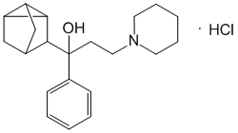
alpha-Phenyl-alpha-tricyclo[2.2.1.0 2,6]-hept-2-yl-1-piperidinylpropanol
In terms of chemical structure and pharmacological properties, it is close to cyclodol. It is used in the treatment of Parkinsonism. In some cases, it is better absorbed than cyclodol and has a more pronounced effect. Set in. A compound close to this substance is considered to be biperiden.

Biperiden (Akineton)
alpha-(bicyclo[2.2.1]hept-5-en-2-yl)-alpha-phenyl-1-piperidinpropanol
Biperiden provides myotropic and spasmolytic effects by blocking central N-cholinoreceptors and peripheral M-cholinoreceptors. Biperiden is used in Parkinson's disease and some movement disorders related to medications. It is used internally or intravenously and intramuscularly. Metabolism of biperiden:

→→
Tropazine (Diphenyltropin)
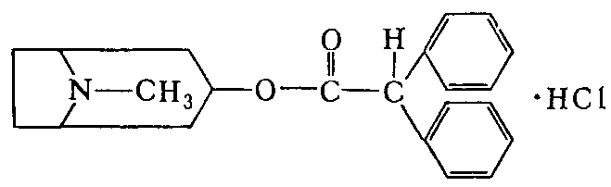
Tropine Ester of Diphenylacetic Acid.
According to the chemical nature of tropacine, diphenylacetic acid is the hydrochloride of tropine ester. To get it, tropine is heated in a benzene solution with chloroanhydride of diphenylacetic acid at a temperature of 80oC. At this time, tropazine precipitates, and it is purified by crystallization from isopropyl alcohol.
Tropacin is a white or slightly yellowish crystalline powder. It is easily soluble in water, alcohol, chloroform, and practically insoluble in ether.
Tropacin is similar in effect to atropine, but the effect of dilating the pupil and reducing the tone of the facial muscles is weak, however, it has a stronger effect on the central cholinergic systems. Ganglion blockade is effective; internal organ eliminates spasm of thigh muscles and blood vessels. Tropasin is a cholinolytic and anti-Parkinson agent, also used in spasms of muscular organs, bronchial asthma, etc. In diseases, the powder is applied in the form of tablets.
Etpenal
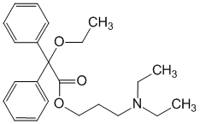

alpha-Ethoxydiphenylacetic acid 2-diethylaminopropyl ester
It is an odorless, bitter-tasting white crystalline powder. Very easily soluble in water, very easily soluble in water. By blocking central and peripheral m/n-cholinoreceptors, it has a spasmolytic and local anesthetic effect. Reduces the symptoms of Parkinson's disease (muscle rigidity and tremor, hyperkinesia). It is produced in tablet form.
Dinesin (Antipar)
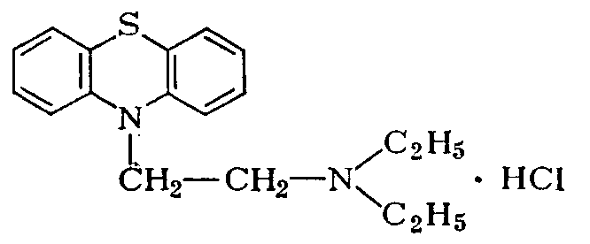
10-(2-diethylaminoethyl)-phenothiazine-hydrochloride
It is a white crystalline powder, easily soluble in water.
According to its chemical structure, it is close to aminazine and diprazine. The central N-cholinergic effect of Dinesin has ganglioblocking properties. Peripheral M-chlorinolytic effect is less pronounced. Dinezin is used in the treatment of parkinsonism and torsion dystonia. It is released in the form of tablets.
Amantadines
Amantadine

1
2
3
4
5
6
7
8
9
1
0
N
H
2
.
H
C
l
1-aminoadamantane-hydrochloride or tricyclo [3.3. 1.1.3.7] decan-1-amine

Receiving:
+

B
r
1
5
0
o
C
-

H
B
r
B
r
N
H
3
-

H
B
r
N
H
2
H
C
l
p
r
e
p
a
r
a
t

It is a white crystalline powder with a bitter taste. Soluble in water, easily soluble in alcohol.
Its anti-Parkinson effect has not been fully studied. As an antagonist of NMDA-type glutamate receptors, amantadine inhibits the reuptake of dopamine and increases its release.
Currently, it is used in the treatment of parkinsonism (Parkinson's disease). It is released in 0.1g tablets, PK Mers in 0.1g tablets and 0.04% solution in a vial (500ml) for infusion.

Gludantane
1
0
2
1
5
4
3
N
H
6
7
8
9
O
C
O
O
H
O
H
O
H
O
H
H
H
H
H
H
Glucuronide of 1-aminoadamantane (midantane).
White or off-white yolks are crystalline powders. Easily soluble in water, slightly soluble in alcohol.
Synthesis:
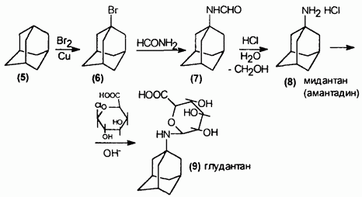

It is used in Parkinson's disease and parkinsonism of various origins. Due to its antiviral effect, it is used in viral diseases of the eye, its 0.5% solution is released in 10 ml vials and 0.2 g tablets.
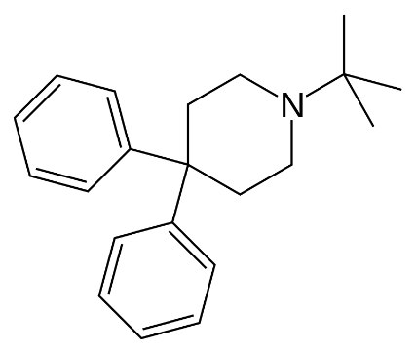

1-tert-butyl-4,4-dienepiperidine
Budipine is an antagonist of excitatory amino acids. The mechanism of action is not yet fully understood. It is believed that the drug increases the synthesis of dopamine as an NMDA antagonist. It is used to treat Parkinson's disease.

Levadopa drugs
Levodopa
3-Hydroxy – L-tyrosine or L-3-(3',4'-dioxyphenyl)-2-aminopropionic acid
Levodopa is a white or whitish crystalline powder, slightly soluble in water, insoluble in ethanol, chloroform and ether.
Its poor solubility in water is due to the presence of strong internal bonds.
It is the left isomer.
Synthesis of levodopa occurs from L-tyrosine:
→

R.R-DIPAMP catalyst is used for asymmetric synthesis. U. Knowles was awarded the Nobel Prize in Chemistry in 2001 for the discovery of this reaction
: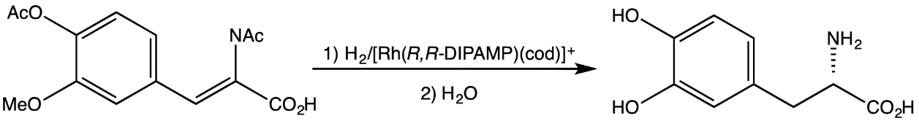
Metabolism of Levodopa:
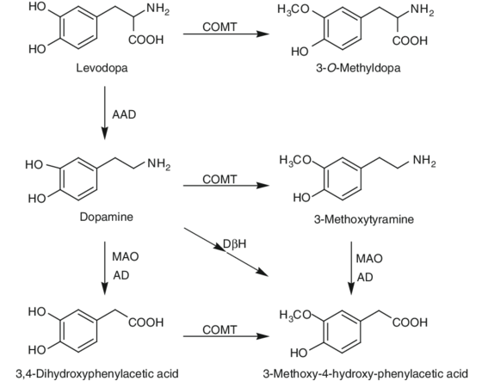

Levodopa relieves the symptoms of Parkinson's disease by increasing the production of dopamine in the brain as a result of decarboxylation. A. Carlson was awarded the 2000 Nobel Prize for the use of levodopa in the treatment of Parkinson's disease.
Levodopa is used in the form of tablets and capsules of 0.25 and 0.5 g.
In recent years, drugs combined with levodopa have been used in the form of "Madopar" and "Nakom".
After oral administration of levodopa, dopamine is rapidly decarboxylated in both brain and extracerebral tissues. As a result, most of the levodopa does not reach the basal ganglia, and peripheral dopamine often causes side effects. Therefore, it is necessary to prevent extracerebral decarboxylation of levodopa. This is achieved by the simultaneous administration of levodopa and benserazide, a peripheral decarboxylase inhibitor.
Carbidopa (Lodosin)
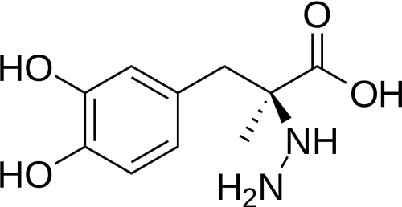

(S)-alpha-hydrazine-3,4-dihydroxy-alda-methylbenzenepropanoic acid
Carbidopa inhibits the decarboxylation of levodopa outside the central nervous system and increases the amount of levodopa entering the brain and its subsequent conversion to dopamine. It is used in the treatment of Parkinson's disease.

Benserazide
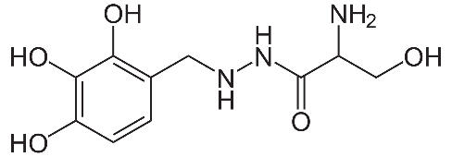

It is an inhibitor of DOFA decarboxylation.
Come on
Combined preparation "Nakom"
"Nakom" is a combined preparation of levodopa, a metabolic precursor of dopamine, and carbidopa, an inhibitor of aromatic amino acids of decarboxylase.
Madopar (Prolopa)
Combination of Levodopa and Benserazide (co-beneldopa). It is used to treat Parkinson's disease.

Monoamine oxidase type B (MAO-B) inhibitors
Seleginile
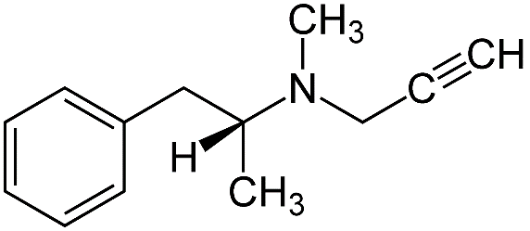
L-(—)-N-(1-phenylisopropyl)-N-methyl-N-2-propynylamine
Synthesis of seleginile:
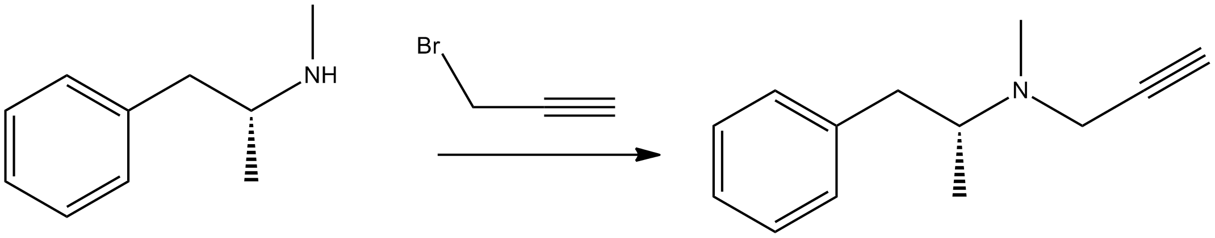

Seleginil (L-deprenyl) was close to ephedrine in its chemical structure. It is a selective inhibitor of monoamine oxidase type B. It is used for the treatment of parkinsonian syndromes of various etiologies related to Parkinson's disease and endogenous dopamine deficiency.
Metabolism of seleginline:
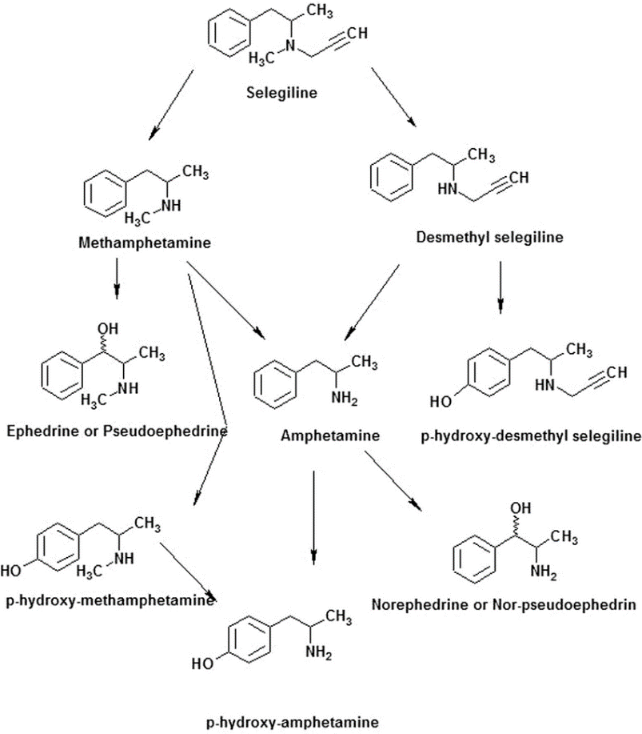
Selegiline can be used together with "Madopar" and "Nakom" drugs.
^{Rasagiline (Azilect)}
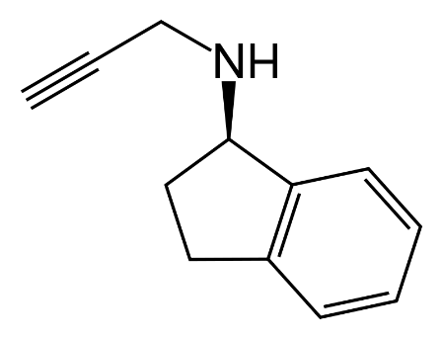
Rosagiline belongs to the second generation of monoamine oxidase type B receptor blockers.
Synthesis:
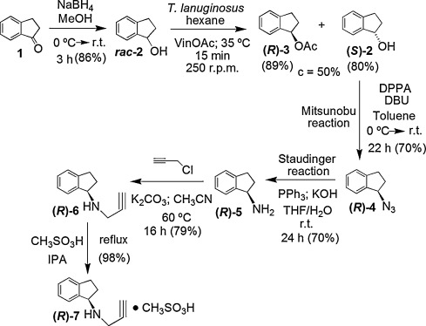

It is used in the treatment of Parkinson's disease and symptomatic parkinsonism. MAO is 14 times more selective against B-type receptors.
Metabolism:
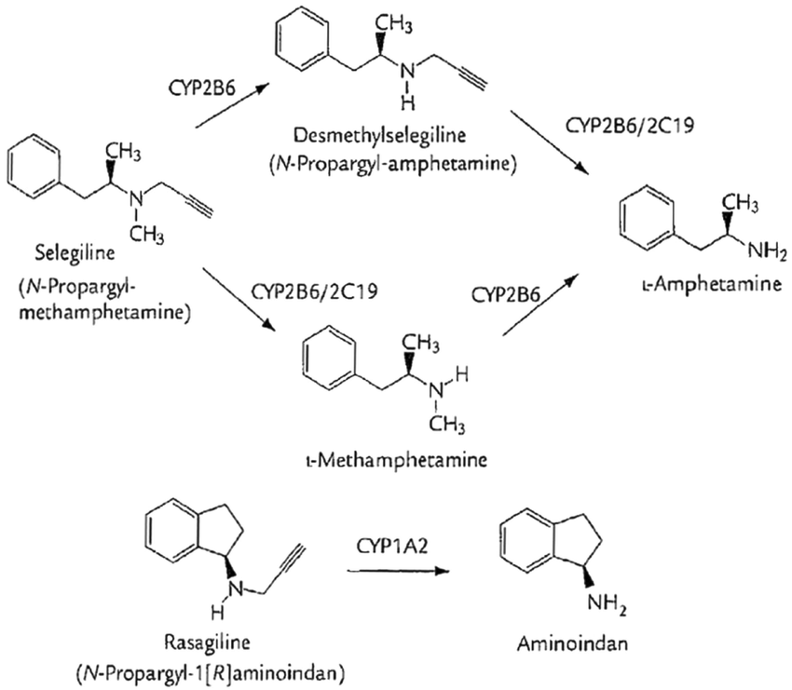
Rozagilin is used in early forms of Parkinson's disease, during mild motor disorders. It can be used together with antiparkinsonian drugs.

Safinamide (Xadago)
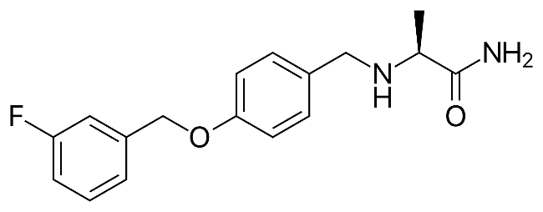
(2S)-2-[[4-[(3-fluorophenyl)methoxy]phenyl] methylamino]propanamide
Synthesis of safinamide:
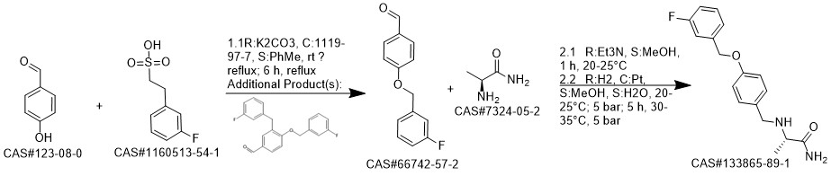
Safinamide is chemically a derivative of alpha-aminoamide.
Metabolism
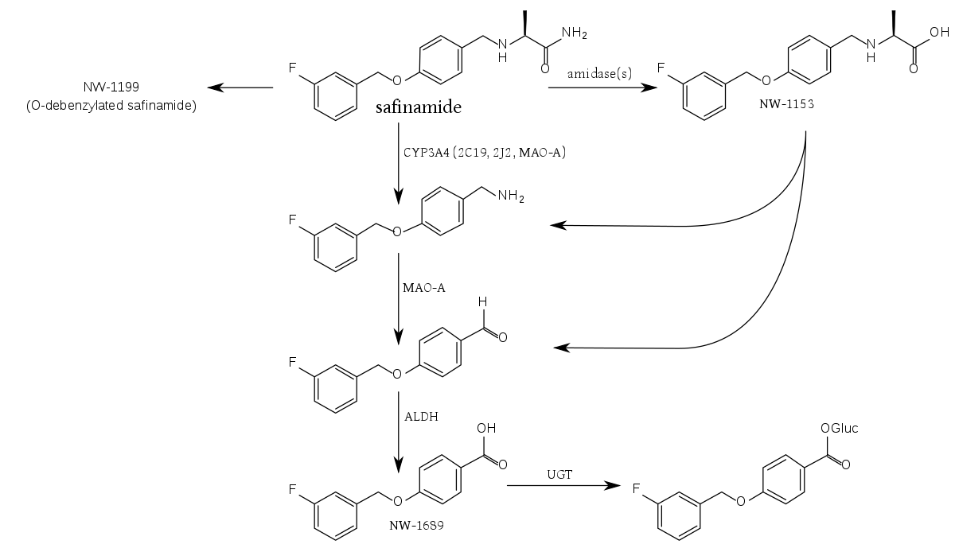
Safinamide is an inhibitor of MAO B-type receptors, acts as a dopamine and glutamate modulator. It selectively and irreversibly inhibits MAO-B. As a result, the reuptake of dopamine is inhibited and the intracellular concentration of dopamine in the striatum increases.

Catechol-O-methyl-transferase (COMT) inhibitors
Tolcapone (Tasmar)
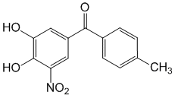
3,4-dihydroxy-4'-methyl-5-nitrobenzophenone
Synthesis:
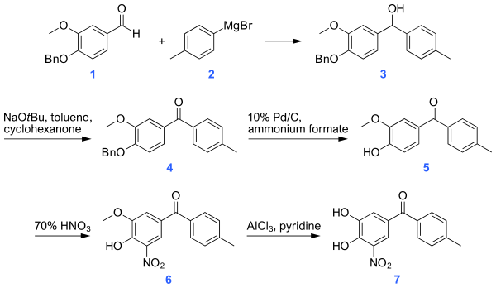
By blocking catechol-O-methyltransferase, it stops the biotransformation of levodopa co-administered with it. As a result, it increases the level of levodopa in the plasma and strengthens its therapeutic effect.
Metabolism:

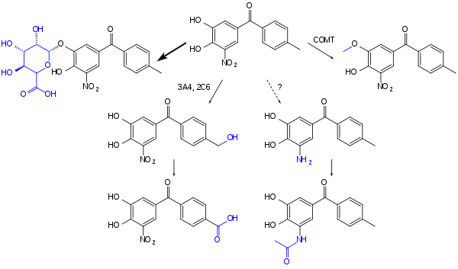

In the treatment of Parkinson's disease, levodopa/benserazide is used together with levodopa/carbidopa drugs.

Entacapone (Comtan)
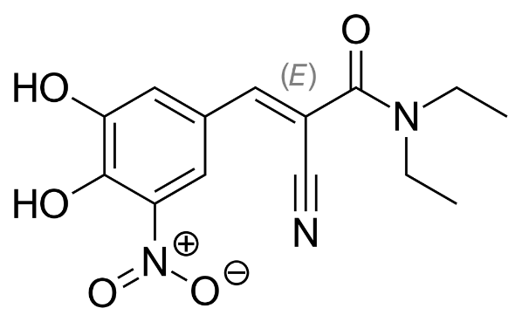

Concomitant use of entacapone with levadopa and carbidopa allows levadopa to have a longer-lasting effect and, as a result, provides longer-lasting relief of the signs and symptoms of Parkinson's disease.
Entecapone is a selective and reversible inhibitor of catechol-O-methyltransferase. When used together with levodopa and carbidopa, Entecapone prevents the breakdown and metabolism of levodopa by catechol-O-methyltransferase, thereby increasing levodopa levels in the brain and in the body as a whole.
In recent years, the drug "Stalevo" offered by the company "Orion pharma" and sold by the company "Novartis" is widely used in the treatment of Parkinson's disease. It contains entacapone/levodopa/carbidopa.

Dopamine receptor agonists
Piribedil (Pronoran)
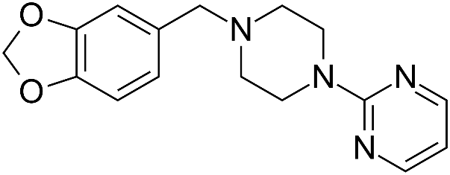

Piribedil is a piperazine derivative anti-parkinsonism drug. Piribedil is an agonist of D2 and D3 dopamine receptors. Also α 2

Pramipexole (Mirapex)
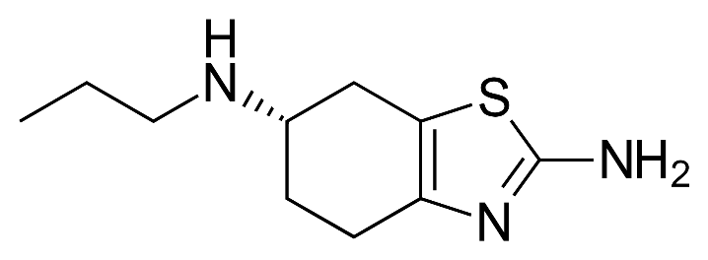

Pramixol is used to treat Parkinson's disease and restless legs syndrome. It is used both in monotherapy and in combination with levadopa in Parkinson's disease. The non-ergoline class is a dopamine antagonist. Its dopaminergic or non-dopaminergic effects depend on its stereoisomers. Its R-isomer has a lower affinity for dopamine receptors (unlike the S-isomer). By acting as an agonist on D2, D3, and D4 dopamine receptors, pramipexole affects dopamine receptors that are insufficiently active in the striatum, which are necessary for the proper functioning of the basal ganglia.
Riponirol (Requip)
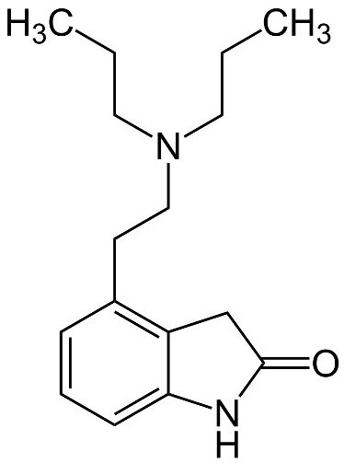

As an agonist of dopamine D2 receptors, Riponirol is used in the treatment of Parkinson's disease and restless legs syndrome. Eliminates extrapyramidal symptoms. At the same time, it can eliminate side effects caused by serotonin reuptake inhibitors and sexual and erectile dysfunction caused by neuroleptics.

Rotigotine
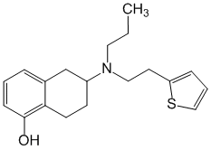
(S)-6-[propyl-(2-thiophen-2-ylethyl)amine]-5,6,7,8-tetrahydronaphthalen-1-ol
It is a non-ergoline agonist of D1-3-dopamine receptors. Its therapeutic effect is related to the activation of D3, D2 and D1-dopamine receptors of the caudate-putamenal complex of the brain. Rotigoline reduces clinical symptoms in idiopathic Parkinson's disease.
Apomorphine
C
H
3
N
O
H
O
H
1
2
3
4
5
6
7
8
9
1
0
3
/
4
H
2
O
.
HCl

It is a white, light gray or light yellowish crystalline powder, odorless. Moderately soluble in water and alcohol. Water solutions turn green due to air and light and lose their activity.
As apomorphine passes through the blood-brain barrier and exerts a central dopaminergic effect, the possibility of its use in the treatment of Parkinson's disease is being investigated. Apomorphine has an antiparkinsonian effect, but it is not widely used in medical practice for this purpose.
Bromocriptine
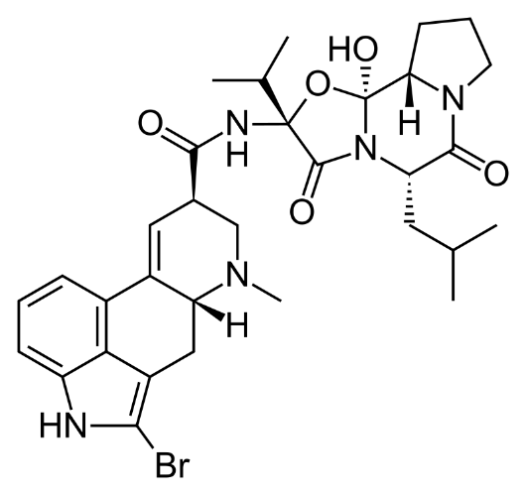
Bromocriptine is a stimulant of central and peripheral D2-dopamine receptors. The drug affects the circulation of dopamine and noradrenaline in the CNS, reduces the secretion of serotonin. As dopamine has a stimulating effect on the receptors in the hypothalamus, it slows down the synthesis of the hormones of the anterior lobe of the pituitary gland, mainly prolactin and somatotropin. Bromocriptine is used in Parkinson's disease, in all stages of its idiopathic form, and in the treatment of postencephalitic parkinsonism.
Cabergoline
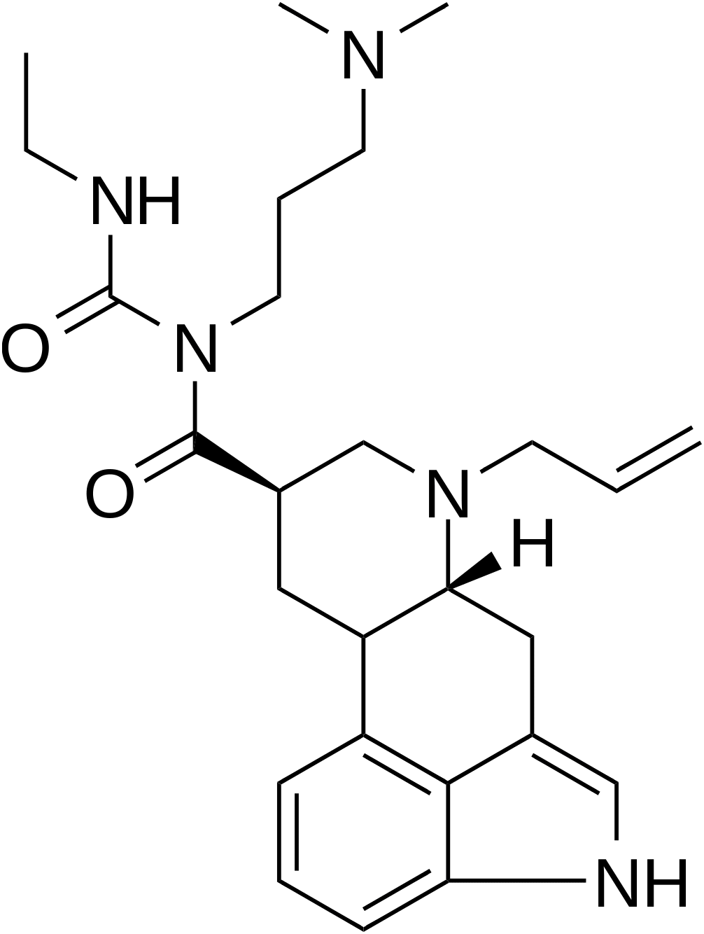

1-[(6-allylergolin-8beta-yl)carbonyl]-1-[3-(dimethylamino)propyl]-3-ethylurea
Cabergoline is a dopaminergic derivative of ergoline, characterized by a marked and long-lasting prolactinizing effect due to the direct stimulation of D2-dopamine receptors of pituitary lactotrope cells. In addition, cabergoline has a central dopaminergic effect due to the stimulation of D2 - dopamine receptors when used in higher doses than those used to reduce the concentration of prolactin in the blood plasma.
A decrease in the concentration of prolactin in the blood plasma is noted within 3 hours after taking the drug, it is maintained for 7-28 days in healthy volunteers and patients with hyperprolactinemia, and for 14-21 days in postpartum women. Cabergoline has a selective effect, does not affect the basal secretion of cortisol and other pituitary hormones. The prolactin-lowering effect of the drug depends on the dose both on the level of expression and on the duration of the effect. The pharmacodynamic effects of cabergoline, which are not related to the therapeutic effect, include only lowering of arterial pressure. The maximum hypotensive effect is observed within the first 6 hours after a single administration of the drug and depends on the dose.
Cabergoline in the treatment of early phase Parkinson's disease. In combination with levodopa and carbidopa, it is used in the progressive phase of Parkinson's disease.

Lizurid (Dopergin)
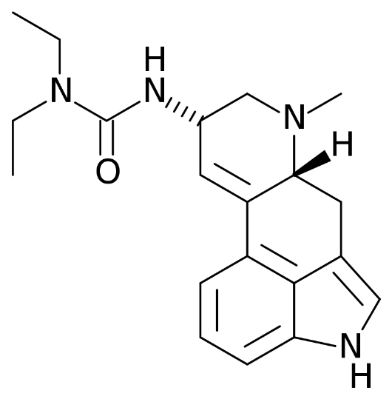
Lizurid is a monoaminergic drug of the ergoline class used in the treatment of Parkinson's disease, migraine, and hyperprolactinemia. It is accepted. Lizurid acts as a mixed agonist and antagonist of dopamine, serotonin and adrenergic receptors. It is believed that the activation of specific dopamine receptors provides its effect in Parkinson's disease.
Pergolide
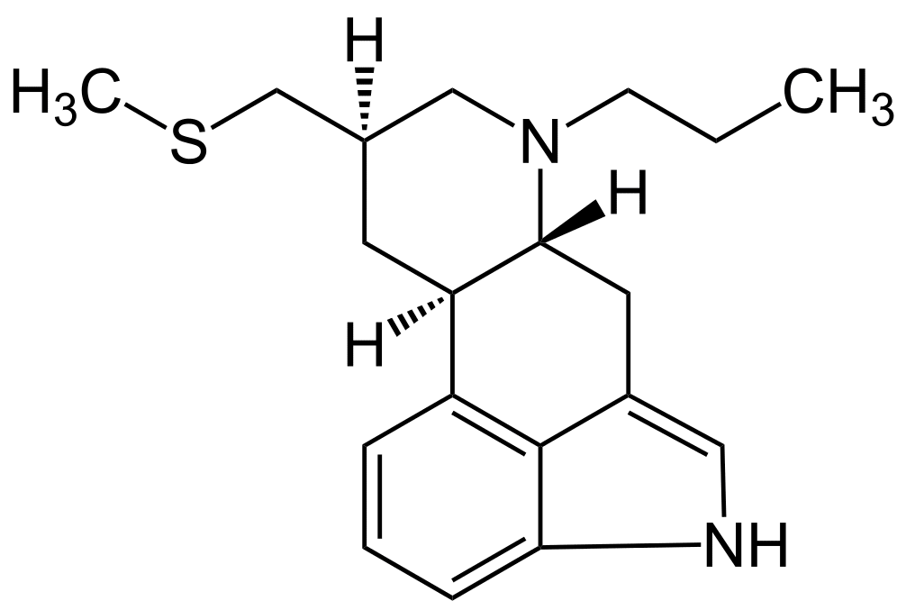

(8beta)-8-[(methylthio)methyl]-6-propylergoline
Ergoline is an agonist of dopamine receptors. Stimulates postsynaptic D1 and D2 dopamine receptors of the nigrostriatal system of the brain. Suppresses the synthesis of prolactin. It is used in combination with levodopa/carbidopa in the treatment of Parkinson's disease.

Other medicines
Clozapine (Azaleptin)
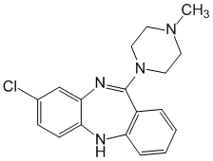

8-chloro-11-(4-methyl-1-piperazinyl)-5H-dibezn[b,e][1,4]diazepine
It blocks dopamine receptors in the CNS, preventing dopamine transmission in the basal ganglia and limbic part of the brain. It has a weak blocking effect on D1-, D2-, D3- and D5 receptors, and has a pronounced effect on D4-receptors. It also has central and peripheral alpha-adrenolytic effects, is an antagonist of histaminergic and serotoninergic receptors. The use of clozapine in Parkinson's disease has given a very high result in terms of eliminating its psychotic symptoms.
Modafinil
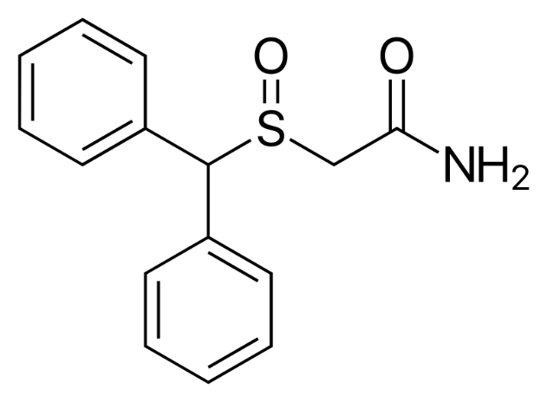
(±)-2-(diphenylmethyl)-sulfinyl acetamide
Modafinil is an analeptic used for the drowsiness associated with narcolepsy. The FDA has also approved it for use in sleep disorders related to shift work. Modafinil is used for daytime sleepiness in Parkinson's disease.
Atomoxetine (Strattera)
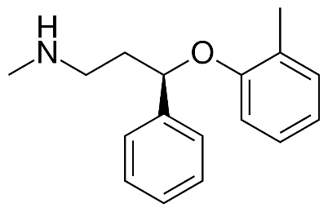
(3R)-N-methyl-3-(2-methylphenoxy)-3-phenylpropan-1-amine
It is a drug used in the diagnosis of attention deficit syndrome and hyperactivity. Atomoxetine is a noradrenaline reuptake inhibitor (centrally acting indirect sympathomimetic) used in Parkinson's disease.
Donepezil
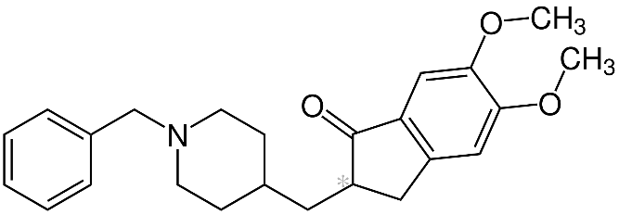
(RS)-2-[(1-benzyl-4-piperidyl)methyl]- 5,6-dimethoxy-2,3-dihydroinden-1-one
Donepezil is a centrally acting acetylcholinesterase inhibitor. It is mainly used in the treatment of Alzheimer's disease. Preliminary studies have shown that the use of donepezil in Parkinson's disease reduces the number of falls in patients. During the study, patients who received donepezil had 2 times less falls.
Atypical neuroleptics that can be used in the treatment of Parkinson's disease:
Quetiapine (Seroquel)
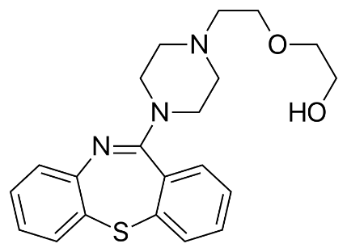
Quetiapine is an atypical neuroleptic used in the treatment of chronic and acute schizophrenia, bipolar affective disorder, major depressive disorder, and some other psychiatric disorders.
Ziprasidone (Zeldox)
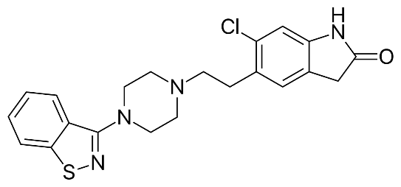
5-{2-[4-(1,2-Benzisothiazol-3-yl)-1-piperazinyl]-ethyl}-6-chloro-1,3-dihydro-2H-indol-2-one
Ziprasidone is an antagonist of 5-HT2A-serotonin receptors and D2-dopaminergic receptors.
Aripiprazole (Aristada)
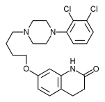
7-[4-[4-(2,3-dichlorophenyl)piperazin-1-yl]butoxy]-3,4-dihydro-1H-quinolin-2-one
In addition to antagonizing D2-dopamine receptors in the mesolimbic pathway, aripiprazole has a unique partial agonist effect in the mesocortical pathway.
Paliperidone (Invega)
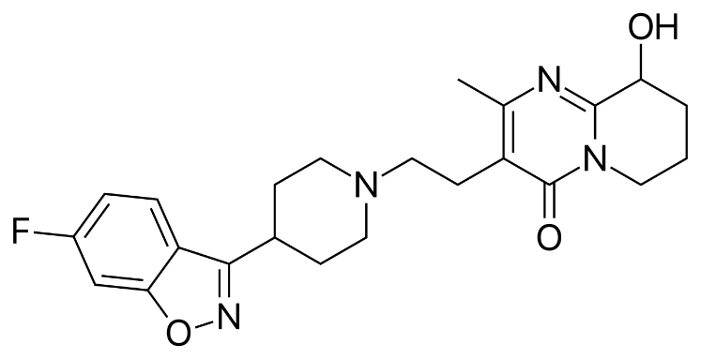
(RS)-3-[2-[4-(6-fluoro-1,2-benzoxazol-3-yl)piperidin-1-yl]ethyl]-9-hydroxy-2-methyl-6,7,8, 9-tetrahydropyrido[1,2-α]pyrimidin-4-one
Paliperidone is a centrally acting D2-dopamine receptor antagonist. It also has high antagonism against 5-HT2-serotonin receptors. It also has an antagonistic effect against α1- and α2-adrenoreceptors and H1-histamine receptors.

